**AFZAL GHANI**

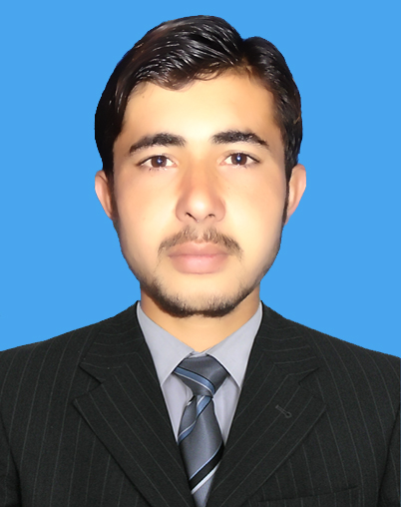

**(DAE Mechanical)**

## **CAREER OBJECTIVE:**

To work in a challenging environment so as to apply my technical skills and theoretical knowledge for hand on experience and contribute to the progress of organization.

## **PERSONAL INFORMATION:**

**Name : Afzal Ghani**

**F/Name : Kabal Ghani**

**Date of Birth : January 09, 1998.**

**Religion : Islam.**

**Nationality : Pakistani.**

**Gender : Male.**

**CNIC No : 16101-9828160-1.**

**Domicile : Mardan (KPK).**

## **ADDRESS:**

**Contact No:** +92-343-91999558 **Email:** [Afzalghani74@gmail.com](mailto:Afzalghani74@gmail.com)

**Address:** Moh: Bala Mian Gan, Village & P/O Khoi Barmol, Tehsil Katlang

Distt: Mardan (KPK), Pakistan.

## **EDUCATIONAL QUALIFICATIONS:**

|  |  |  |  |
| --- | --- | --- | --- |
| Degree/Certificate | Marks Obtained | % Marks | Board/Institution |
| D.A.E (Mechanical) | **2449/ 3450** | **71** | **KPK BTE PESHAWAR** |
| Matric | **766/1100** | **70** | **BISE MARDAN** |

## **ACADEMIC PROJECT:**

* Sand Filter Machine

## **SKILLS:**

* Power point
* AutoCAD Civil 2006
* MS Word
* MS Excel

## **HOBBIES:**

* Reading books,
* Playing Cricket
* Foot Ball

## **Experience:**

* Prime Minister Youth Training Program ( In Progress)