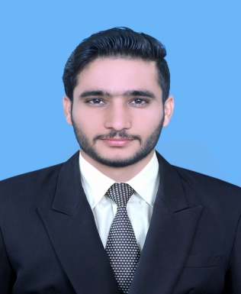

***MUHAMMAD SUFYAN***

***SHABBIR***

***S/O:*** *MUHAMMAD SHABBIR*

***Email Address*:** *mohammadsufyan530@yahoo.com*

***Cell No:*** *+92-305-5578534*

***Postal Address:***

*CHAK NO. 530GB, NARUNGWAL, TEHSEEL SAMUNDRI, DISTRICT FAISALABAD. PO SAME.*

***Home Address:***

*CHAK NO. 530GB, NARUNGWAL, TEHSEEL SAMUNDRI, DISTRICT FAISALABAD.*

***Marital Status:*** *Single*

***Religion:*** *ISLAM*

***Gender:*** *Male*

***Nationality:*** *Pakistani* ***CNIC:*** *33105-0675034-3*

***Date of Birth:*** *14-01-1997*

***Computer Skills:***

* *Operating Systems(Windows)*
* *MS Office (MS Word, MS Excel, MS Power Point).*

***Major Software Skills:***

* *Solid Works.*
* *Oracle.*
* *Mastercam.*
* *Advanced MS Excel.*

*References:*

*Provided on demand.*

**Curriculum Vitae**

***Career Objective:***

*To work with an aim,to gain valuable hands on experience and professional skills*

*in an organization, which provides a challenging, learning and developing skills.*

***Academic Qualification:***

|  |  |  |  |
| --- | --- | --- | --- |
| ***Degree*** | ***Institution*** | ***Duration*** | ***Marks / Grade*** |
| *BS(Mechanical Engineering)* | *COMSATS Institute Of Information Technology, Islamabad* | *2013-2017* | *74% , B Grade* |
| *HSSC* | *BISE FAISALABAD* | *2011-2013* | *71% , A Grade* |
| *SSC* | *BISEFAISALABAD* | *2009-2011* | *82% , A+ Grade* |

***Professional Experience:***

*Currently working in SUI Northern Gas Pipelines Limited as* ***“Engineer”*** *in Metering Department for Domestic Meter Inspection Shop at Faisalabad (D) on contract basis for a period of one year.*

***Certificates:***

* *Two months internship certificate at NISHAT Industries (pvt).*
* *Certificate of Senior -Organizer at COMSATS research society (C R S).*
* *Certificates of winning “LIFT YOUR DRINK’16” (ASME ).*
* *English Language Proficiency Certificate holder.*

***Professional Skills:***

* *Advance Report Writing skills.*
* *Strong communication and analytical skills.*
* *Knowledge of HSE Procedures and Practices.*
* *Good Numerical skills.*
* *Material Handling and Management skills.*
* *Installation of mini-projects like compressors.*

***Academic Projects:***

* *Design and fabrication of upper body of DICE-car(Final Year Project).*
* *Design and Fabrication of Automatic page turner.*
* *Fabrication of water level indicator.*
* *Design and Fabrication of Buckling Apparatus for Lab.*
* *Proto-type of fire tube boiler.*