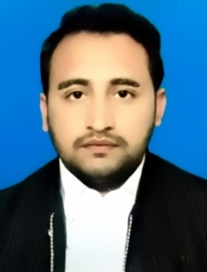WAQAS SHAH

Contact address:Village Dagbehsud Post office Pabbi station

Tehsil Pabbi District Nowshera KPK

**Mobile:** +92312 9022971

**E-mail:** waqasuet2396@gmail.com

**Objective**

To achieve a career in a competitive organization that will help me to polish my abilities and to

secure a responsible and challenging position where i can contribute to the growth of both the

prospective organization and myself

**Work Experience**

* **Interenship in Pakistan Broadcasting corporation 2 Weeks**
  + - Radio Pakistan Peshawar
* **Internship in Grid station 2 Months**
  + - 132kv City Grid station Peshawar

**Final Year Project**

Fast Faut Detection For Power Distribution System Grade A

Education

2013-2017 BS Electrical (Communication)

University of Engineering and Technology Peshawar (mardan campus)

1st division

2011-2013 Intermediate (Fsc Pre Engineering)

Board of intermediate & Secondary Education, Peshawar

1st division

2009-2011 Matriculation (Science)

Board of intermediate & Secondary Education, Mardan

1st division

Personal Profile

Father Name : Abdullah Shah

CNIC No: 17201-1009880-5

Religion: Islam

Date of birth: 23 March 1996

Marital status: Single

**Skills**

* Good written and verbal communication skills.
* Reading, writing and speaking different languages (English ,Urdu and pushto)
* Using different computer software (Ms office ,Ulead, Photoshop,MATLAB,Cisco Packet tracer,

Work Bench,Programming C & C++)

Reference

Furnished upon request