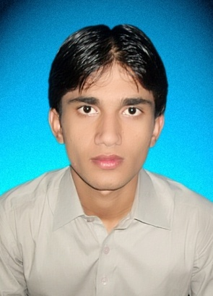

Lal karyana P O box Samaro Road Talka Samaro District Umerkot Sindh Pakistan

Email Id: [mathanakhani1991@gmail.com](mailto:mathanakhani1991@gmail.com) Contact No: +923353512434

***Mathan Chakar Wati***

Objective:

My Objective is to Make the best use of my Knowledge in order to contribute for organizational Objectives to the best of my ability.

Personal Data:

* FATHER’S NAME: Bhomji Mal
* DATE OF BIRTH: 20-08-1991
* CNIC NO: 44106-2423706-1
* PASS PORT No: BC4167061 (Exp: 11-jan-2020)
* NATIONALITY: Pakistani
* RELIGION: NON Muslim

Academic Qualification:

|  |  |  |  |  |
| --- | --- | --- | --- | --- |
| S.NO | DEGREE | GRADE/DIVISION | YEAR | BOARD/UNIVERSITY |
| 1 | B.E Mining | **Ist** | 2013 | Muet Jamshoro |
| 2 | Intermediate | A | 2009 | B.I.S.E Mirpurkhas |
| 3 | Matriculation | A.1 | 2007 | B.I.S.E Mirpurkhas |

Professional Certificate:

* CIT(Certificate in information Technology)
* Iosh Managing Safely 3.1
* Hazards Communication
* Confined Space Safely
* Scaffolding Safely

Experience:

* Seven year home tuition 3rd to 10th (March 2010 to March 2017)
* Math’s & Computer Teacher @ High Star Model School Tilak chari Hyderabad

(March 2014 to Sept 2016).

* Data Entry Operator @ High Star Model School Tilak chari Hyderabad

(oct 2016 to March 2017).

* Intern @ Sindh education Foundation Dist: Office Umerkot (April 2017 to present).

Technical Visit:

* Power Cement Limited Noriabad
* Lakhra Coal Development Company(LCDC)
* Lakhra Coal Power Plant Jamshoro
* Khewra Salt Mine Lahore
* Limestone Quarry Noriabad
* Pakistan Steel Mill Karachi.

Professional Experience:

* Ms Window XP 2007,2010
* Ms Office, Excel, PowerPoint, Access & Internet Browsing
* Experience about Mathematic & computer subject teaching
* Look All Office Administration/Finance matter.
* Facilitate all program district activities
* Facilitate entrepreneurs for Academic point of view
* Visit school to facilitate the teacher for Academic point of view
* Sharing new ideas to teacher about academic
* Close communication with coordinator in every task
* To achieve the assigned target timely
* Provide support to coordinator in assessing & reporting on the field activities
* Provide support to coordinator to arrange & manage teacher training at District level
* Good Quality of Leadership
* Excellent Behavioral
* Analytical Mind
* Polite Nature
* Excellent Communication

Skill:

* Safety Inspection Hazard Identification
* Risk Assessment Fire Safety
* Scaffolding Safety Confined Space Safety
* Safety Culture Permit To Work
* Explosive Knowledge Blasting Knowledge
* Underground Mine Knowledge Surface Mine Knowledge
* Daily Limestone Quarries Inspection report Knowledge about Drilling
* Monthly Mineral Consumptions report
* Knowledge About Cement Manufacturing

Hobbies:

* Communication Skill: English Urdu Sindhi
* Informative: Newspaper, Internet & Books
* Travelling: News Places & Meeting with New People