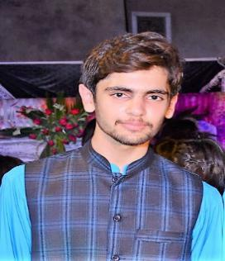 WASSAM AHMAD

Mobile +92-3316846646

E-mail Personal wassam3443@gmail.com

|  |  |  |
| --- | --- | --- |
| **EDUCATION** |  |  |

 **B.Sc – Mechanical Engineering** **3.37 on the scale of 4.**0 _________________**2014 – 2018**

SWEDISH COLLAGE OF ENGINEERING & TECHNOLOGY (Affiliated with UET TAXILA) Wah Cantt, PAK



**702/1100**

**2012**

**–**

**2014**

LAYYAH,PAK

IIISDSSDDSDSSSSSSSSSSSSSSSSSSSSSSSSSSS

**836/1050**

________________________________

_

**2010**

**–**

**2012**

**HSSC – Pre Engineering**

IBN-E-KHALDOON HIGHER SECONDARY SCHOOL LAYYAH

# SSC – Science

MC HIGH SCHOOL LAYYAH     LAYYAH, PAK

|  |  |  |
| --- | --- | --- |
| **CARRIER OBJECTIVE** |  |  |

To pursue my career in a competitive environment where my engineering and management skills get challenged so that I get to apply my knowledge to the best of my abilities and gain more experience regarding

my field.

## SEMESTER PROJECTS

* **CAD/CAM:** Modeling of gear trains in Solid Works.
* **Thermodynamics:** Design and Study of Gas Turbine Engines.
* **Electrical Engineering:** Design and Fabrication of Water level indicator.
* **Design of Machine Elements:** Design Suspension Spring System of a Car.
* **Fluid Mechanics-II:** Design and Fabrication of “Hydraulic Brake” at Micro Scale.
* **Measurement and Instrumentation:** Fabrication of Automatic “Sun tracking solar panel”.
* **Engineering Dynamics:** Design and Modeling of Truss Bridge wooden Model.

## FINAL YEAR PROJECT

**Design and Fabrication of Pedal power hacksaw machine:**

The objective of the project is the design and fabrication of hacksaw cutting system that is easier to operate, reduce the human effort and make the cutting process faster with this system. Different materials like Steel, Iron, Aluminum, wood and as well as Plastic cutting of a PVC pipes can be cut and as the same time serve as an exercising machine for fitness.

## TECHNICAL AND COMPUTER SKILLS

* Comfortable skills in ANSYS, AutoCAD, Solid Works, Abaqus and MATLAB.
* Comfortable skills with the use and application of mechanical workshop tools, Laboratory devices and machinery.
* Comfortable skill with Lath Machine at CNC Workshop.
* Conversant with the use and application of MS Office.

**PERSONAL EXPERIANCE**

* Work as an internee at “Duber Khawar Power Station, WAPDA” Pattan Kohistan.