**MUHAMMAD IMRAN** 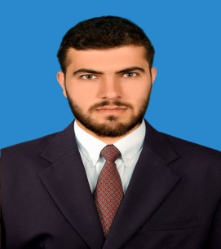

**Contact info.**

**Address:** MES Block (37) House No. (01) near CSD shops Peshawar Cantt

**Cell #:**+92-340-6318553

**Email**: imran.khan2k13che102@gmail.com

**Objective**

To get a position of internee engineer with focus on developing entrepreneurial and technical skills to achieve organizational as well as career goals efficiently.

**Education**

**(2013 – 2017) B.Sc. Chemical Engineering**

NFC-Institute of Engineering & Technology, Multan (NFC-IET)

CGPA 3.10/4 (B)

**(2010 – 2012) HSSC** Punjab College for Boys, Multan 809/1100 (A)

**(2008 – 2010) SSC** Pak land Ideal Public High School Multan 720/1050 (B)

**Experience**

* **Nestle Kabirwala Pakistan**
* Internship (4 weeks) at STD Plant
* **Nishat Textile Mill Lahore**
* Internship (12 weeks) at Waste Water Treatment Plant
* **Master Textile Mill**
* Doing job as MTO in washing section

**Industrial Visits**

* Industrial visit at FFC(Fauji Fertilizer Company), Mari Petroleum & Gas Field, OGDCL,PAK ARAB Fertilizer, Best-Way Cement , Packages Lahore, Fatima Fertilizers.

**Certifications**

* Participated in Computational Fluid Dynamics (ANSYS) Workshop.
* Participated in Aspen Plus (Aspen Tech) Workshop.

**Software’s**

* Chem. CAD
* Ansys (FLUENT + Workbench)
* Aspen Plus

**Programming Skills**

* MS (Word, Excel, Power Point)

**Hands ON**

* Managerial and Interpersonal skills
* Strong sense of responsibility and self-motivation
* Time management
* Reporting skills

**Interests**

* Cricket
* Current Affairs
* Social Networking
* Islamic Books

**Personal Data**

* Gender: Male
* Nationality: Pakistani
* Marital Status: Single
* Date of Birth: 05th Sep,1994