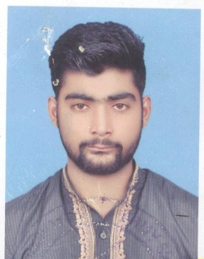

***ASIM MAZHAR***

***OBJECTIVE***

**To commence my Career with an organization this provides a congenial work environment and an atmosphere conducive to learning and career progression.**

***PERSONAL PROFILE***

**Father’s Name** **:** **MAZHAR HUSSAIN**

**Date of Birth** **:** **06-04-1999**

**Religion** **:** **Islam**

**Domicile** **:** **Jhang**

**C.N.I.C #** **:** **33203-9975294-3**

**Gander**  **:** **Male**

**Marital Status** **:** **UnMarried**

**Nationality**  **:** **Pakistani**

**Address : Mohallah Abduallah Bin Abbas Ward No 1. Tehsil Shorkot Distt J Jhang**

**Cell # : 0306-6005382**

***MARKS SHEET***

|  |  |  |  |
| --- | --- | --- | --- |
| **DEGREE** | **YEAR** | **Marks** | **BOARD** |
| **MATRIC** | **2014** | **696/1100** | **BISE FSD** |
| **FSc** | **2018** | **593/1100** | **BISE FSD** |

***LANGUAGE***

***DIPLOMA***

* **English**
* **Urdu**
* **Punjabi**

***REFERENCE***

* **References will be furnished on demand.**