**Imran Ali**

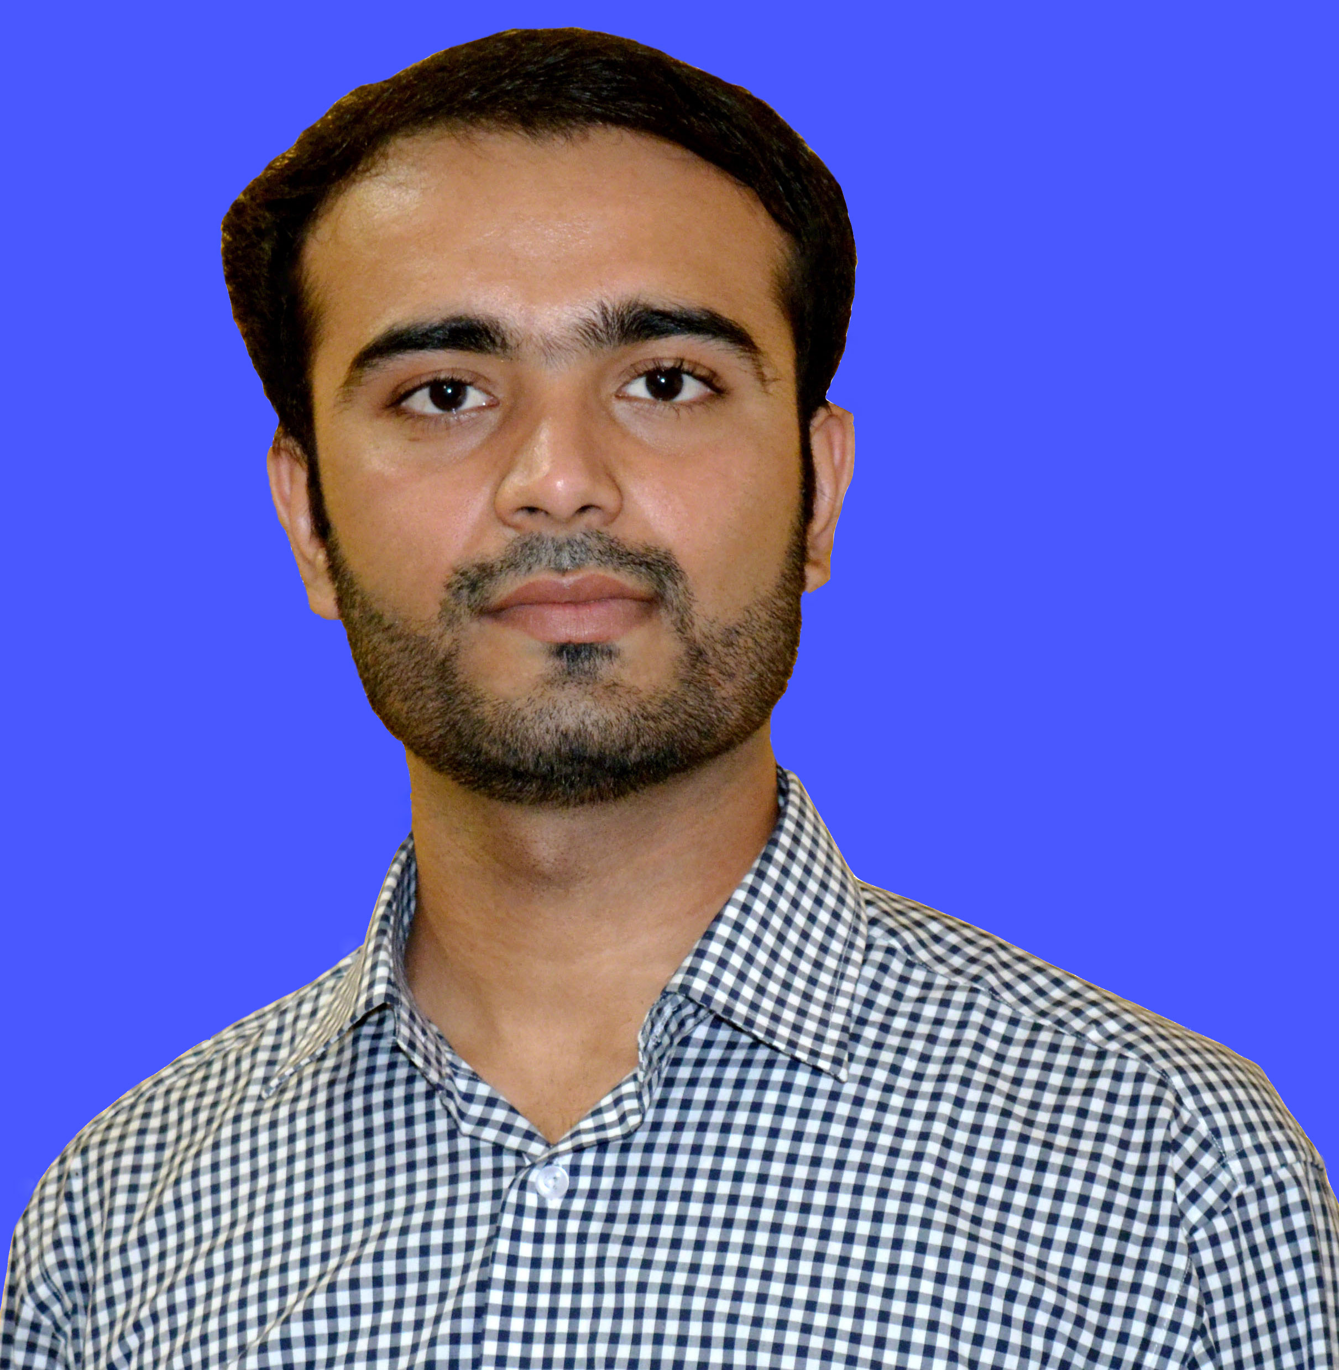

**Electrical Engineer**  +923337055104 imranalihalepoto@gmail.com



I am a graduate of Electrical Engineering who is ambitious to learn, grow and succeed by fair and ethical means. I  
am that sort of a person who has the natural ability to provide excellent service within a challenging environment.



**WORK EXPERIENCE**

**Electrical Engineer**



***JPCL* (Internee at Jamshoro Power Company limited).**

Provide efficient solutions for the processes of the Power Generation ,Transmission and Distribution.



 Involved in the management of people, projects and resources, as well as the development and use of new materials and technologies.



Designing and implementing cost-effective equipment modifications to help improve safety and reliability



Discussing and solving the problems of Power Outages and Power management in the Region.



Working with other professionals, within & outside the engineering sector.



* **Training Course in Entrepreneurship(NEP) IBA Karachi 2017**
* **Assistant Team Leader in Final Year Project.**
* **Worked for NIP internship program as Representative internee for Govt. Sectors for 1 year**
* **Member of IEEE (Institute of Electrical and Electronics Engineers) MUET branch for 2 years.**
* **Participant at 4th International Muiti-Topic Conference 2015**
* **Organizer For Seminar on "Smart Grid and Its Application" 2013**

**TECHNICAL SKILLS**

MATLAB



NI Multisim



Web Designing



Risk management



Microsoft Office



Internet/Emails



Working Capital Management



Interpersonal Skills



Communication Skills



Time Management



**PERSONAL SKILLS**

**Ambitious**

**Goal Oriented**

**Innovative**

**Team Player**

**Communicative**

**LANGUAGES**

**English (UK)**



*Professional Working Proficiency*

**Urdu**



*Native or Bilingual*

*Proficiency*

**EDUCATION**

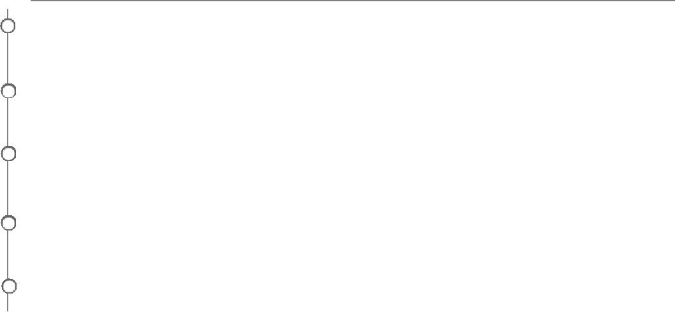

**Bachelors In Electrical Engineering**

***B.E. Electrical* (2013 - 2016) from Mehran University of Engg. & Tech. Jamshoro, PK.**

**Higher Secondary Education –A1 Grade**

***Board of Intermediate & Secondary Education, Sukkur Sindh* (2011–2012)**

**Matriculation- A1-Grade**

***Board of Intermediate & Secondary Education Sukkur Sindh*.(2009-2010)**



**HOBBIES**



News Cricket Music Games Web Surfing Socializing



**PERSONAL**



**Nationality**

*Pakistani*

**Date of Birth**



*11/1/1995*

**Marital Status**



*Single*

**Driving License**



*Yes*

**ADDRESS AND RELOCATION**



* H# A-37/2 Princetown Phase 2, Qasimabad, Hyderabad
* Willing to relocate and can travel for official assignments.
* Professional reference will be furnished if required.