Junaid Raziq

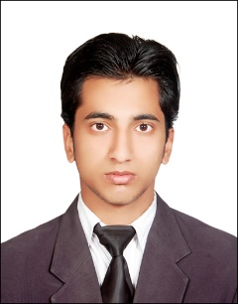

**Mobile :+92-305-9108418**

**junaidraziq@gmail.com**

Name : Junaid Raziq

Father’s Name : Fazal Raziq

Gender : Male

Nationality : Pakistani

Domicile : Mardan (KPK)

DOB : 09/April/1994

**OBJECTIVES**

To enhance the proficiency of my abilities and to do work for the betterment of your organization. I will do my best for the progress and show my best performance in your organization and to continue my career with an organization that will utilize my MANAGEMENT, SUPERVISION & ADMINISTRATIVE skills to benefit mutual growth and success.

**EXPERIENCE**

* **PARINA PHARMA PVT LTD**

Sales Executive At Parina Pharma

August 2017 – January 2018

**ACADEMICQUALIFICATIONS**

|  |  |  |  |
| --- | --- | --- | --- |
| **QUALFICATION** | **Subject** | **YEAR** | **BOARD / UNIVERSITY** |
| BA | English | 2015 | AWKUM |
| FSC | Computer Science | 2013 | Mardan |
| SSC | Science | 2011 | Mardan |

**Computer Skills:**

* Microsoft Office (MS Word, MS Excel, MS PowerPoint)
* Internet Surfing
* Marketing
* Computer Operator
* Data Entry

**Languages:**

* English

* Urdu

* Pashto