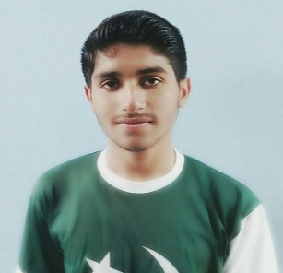  **CV**

**Personal profile:**   
**Full Name:** Muhammad Adeel Arif

**Father’s Name:** Muhammad Arif  
**Date of Birth:** 09-Sep-1996

**CNIC No:** 37405-0752339-9  
**Age:** 22  
**Nationality:** Pakistani  
**Marital status:** Single  
**E-mail:** muhammadadeelarif147@gmail.com   
**Contact:** +923135751908

**Permanent address:** Mohalla Ghosia Masjid Chak Jalal Din Girja Road, Rawalpindi

**Carrier objectives:**

Seeking  a  position  to  utilize  my  skills  and  abilities  in  a  technology  industry that  offers  professional  growth  while  being  resourceful, innovative  and  flexible.

**Experience:**

**Maintenance Field Internship:**

DEWAN CEMENT Hattar, Pakistan (06 September 2017 – 05 October 2017)

IASKARI CEMENT WAH, Pakistan (10 October 2017 – Present)

2 Year Practice in

► Lathe Machine

► Milling Machine

**Qualification profile:**

|  |  |  |  |  |  |
| --- | --- | --- | --- | --- | --- |
| **Qualification** | **Name of the institution** | **University /Board** | **Obtained Marks/Total Marks** | **Grade** | **Year of passing** |
| **Matric** | Rising Star Public School, Rawalpindi | Federal Board of intermediate & Secondary Education Islamabad | 590/1050 | C | 2014 |
| **DAE(Mechanical)** | Rawalpindi Swedish Institute of Technology | Punjab Board of Technical Education, Lahore | 2378/3450 | B | 2017 |

**Languages:**

►Basic English

►Punjabi

►Urdu

**Additional Activities:**

                            ► Reading books

► Listening music

**Hallmarks:**

                      ► Hard worker

                                   ►Good character

**Computer skills :**

                                   ► Basic Computer Skills

                                   ► MS Word

**Hobbies:**

                                   ►Playing

                                   ►Listening Music

                                   ►Playing Games

                                   ►Singing  
  
**Declaration:**  
  
I hereby declare that the information furnished above is true to the best of my knowledge.