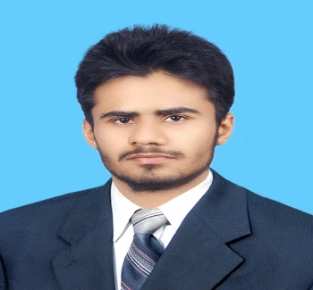Hamza Bashir



Electrical Engineer (Power)

Insightful and focused electrical engineer with combination of academic credentials, analytical agility and relentless enthusiasm towards Electrical machine, Power Generation & power transmission. Equipped with a blend of extensive knowledge on sales and supply chain management, capable of identifying faults in system and producing solutions.



[hamzabashir503@gmail.com](mailto:hamzabashir503@gmail.com)



+92 312 7492298



House#59, Shammas Colony GOR1, Lahore, Pakistan



06 February, 1997



[linkedin.com/in/hamzabashir503](https://www.linkedin.com/in/asadmasood407)



Hamza Bashir



**WORK EXPERIENCE**

**Engineering Intern**

Nishat Mills Limited Power Plant

*06/2016 – 08/2016* *Lahore, Pakistan*

 Monitored C.C.R(Centre control Room), and Engine Room Operations (ERO). Collaborated with the technical staff in services team to maintain the Electrical Parameters.

 Constructed of Pipe and Line Diagram of whole power plant including measurements and Instruments.

Monitored the eﬃciency of 22 MW capacity Wartsila



engines, Boilers and Steam Turbines.

**Digital Marketing Trainee**

Punjab University E-Rozgar

*09/2018 – Till Now* *Lahore, Pakistan*

 Education start up funded by Punjab Government that teaches professional skills to students.

 Learning about Content Marketing and Marketing Funnels.

 Practical Knowledge of SEO (Search Engine Optimization), Blogging and SMM (Social Media Marketing).



**VOLUNTEER EXPERIENCE**

Society of Innovative and Electrical Professionals, UET TAXILA (01/2016 – 05/2018)

Institute of Electrical and Electronics Engineer, UET TAXILA Chapter (05/2016 – 07/2017)



**EDUCATION**

**Electrical Engineering (Power)**

University of Engineering and Technology Taxila, Pakistan.

**SKILLS**



Leadership



Adaptive to working

environment



Logistics Handling



Goal Oriented



Verbal and written

communication



Safety & Risk Assessment



Critical Thinking



Data Acquisition & Processing



Resiliency



Creativity

**INTERESTS**



CCR Generation Power Transmission



Supply Chain Management



Project Management Digital Marketing

**Project: Design and Development of a prototype of Active Denial System (FYP)**

**(2017 – 2018**)

Group leader



Selected for Open House UET Taxila 2018



The Aim of the Project was to design a



[non-lethal](https://en.wikipedia.org/wiki/Non-lethal_weapon), [directed-energy weapon](https://en.wikipedia.org/wiki/Directed-energy_weapon) designed  
 for area denial, perimeter security and crowd  
 control.



Alternative Energy Resources Badminton

***09/2014 – 07/2018* *CGPA 2 .61/4***

**F.Sc(HSSC)Pre-Engineering**

Govt. Farid Bakhsh Ghosia Degree Sc. College

***08/2012 – 07/2014* *940/1100***