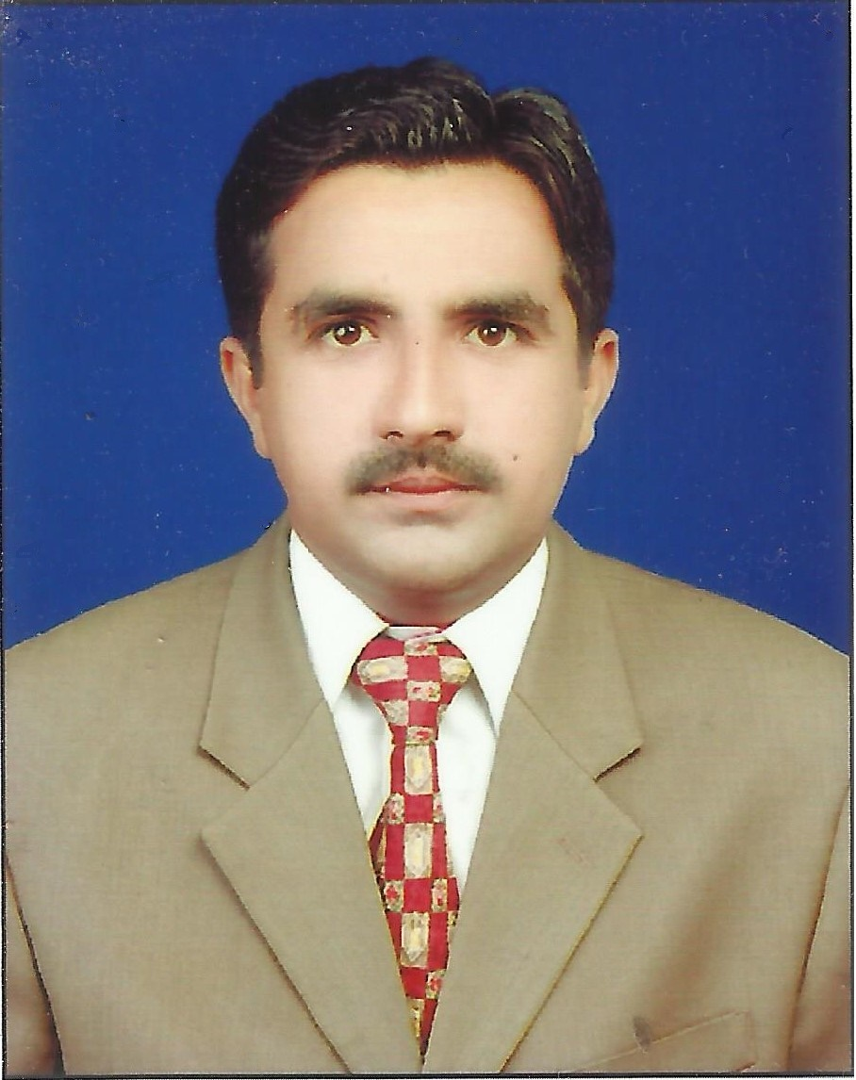

**AHSAN ALI DAHAR**

[***ahsandahar03@gmail.com***](mailto:ahsandahar03@gmail.com)

***Cell: +923103564504***

**CARRIER OBJECTIVE**

To Secure the position in an organization which provides me a professional Environment for contribution learning and growth where I can utilize my skills education and environment.

**PROFESSIONAL QUALIFICATION**

**B.E Mechanical Engineering** from **Quaid-e- Awam University of Engineering Science & Technology Nawabshah with 2.92 CGPA ( 73.21%).**

**PROFESSIONAL EXPERIENCE**

* **Safety Assistant** in **Qatar Gas L.L.C**  **Shutdown** of **Descon Engineering Qatar L.L.C .**

**( from 29 Sept, 2017 to 07th  Nov ,2017)**

**Job Responsibilities**

* Conduct the Tool bx talk.
* Perform the Gas monitoring.
* Check the PPEs of Entrants.
* Write the names of Entrants on on logsheet & time of entry in and out.
* Communicates with the Entrants.
* Stop the work in case of any Emergency & call to the Rescue team.
* Barrication of mainway.
* **Safety Assistant** in **QCHEM Qatar**  **Shutdown** of **Descon Engineering Qatar L.L.C .**

**( from 20 jan, 2017 to 5th  March ,2017)**

* **Trainee Engineer** ( Mechanical) in **Zeal Pak Cement Factory Rohri.** **( from 7th Sep, 2015 to**  **15th Nov, 2016)**
* Follow the instruction given by Managers & perform the tasks.
* Alignment ID fan & Shaft Coupling .
* Overhauling & maintenance of Crusher, stacker, Reclaimer Pre heater Cyclones , Grate cooler plates .
* Repair & maintenance of Belt conveyor, Screw Conveyor ,Bucket Elevator, Blower Pump Compressors & Dust collectors
* To check the workshop manufacturing routine as well as fabrication & machining required.
* Also understanding the working on Baghouse, Bag filters ,Raw Mill, Pre heater, kiln & Cement Mill.

**INTERNSHIPS & TRAININGS**

* **Fire Extinguisher Training** @ **Venture Gulf Training Centre in QATAR.**
* **4 weeks** internship @ **Oil and Gas Development Company Limited (OGDCL)**

Qadir Pur Gas Field Ghotki.

* **8 weeks** internship @ **Zeal Pak Cement Factory Rohri.**

ACHIEVEMENTS

* Final Year Project: Manufacture Steam Turbine for Electricity Generation
* Won 1ST prize in Mini Project competition (Steam Engine).

**KEY SKILLS**

* AutoCAD 2D-3D , MS office

**INTERESTS/HOBBIES**

* Reading Modern Research Article.
* History reading.
* Internet surfing.
* Playing cricket & badminton.

**PERSONAL DATA**

Date of Birth 11-11-1992

Domicile Sukkur

Marital Status Single

Religion Islam

Cell No +923103564504

Permanent Mailing address Hyder House AL-Madina Colony Near B.I.S.E Sukkur,

Sindh, Pakistan.