### 

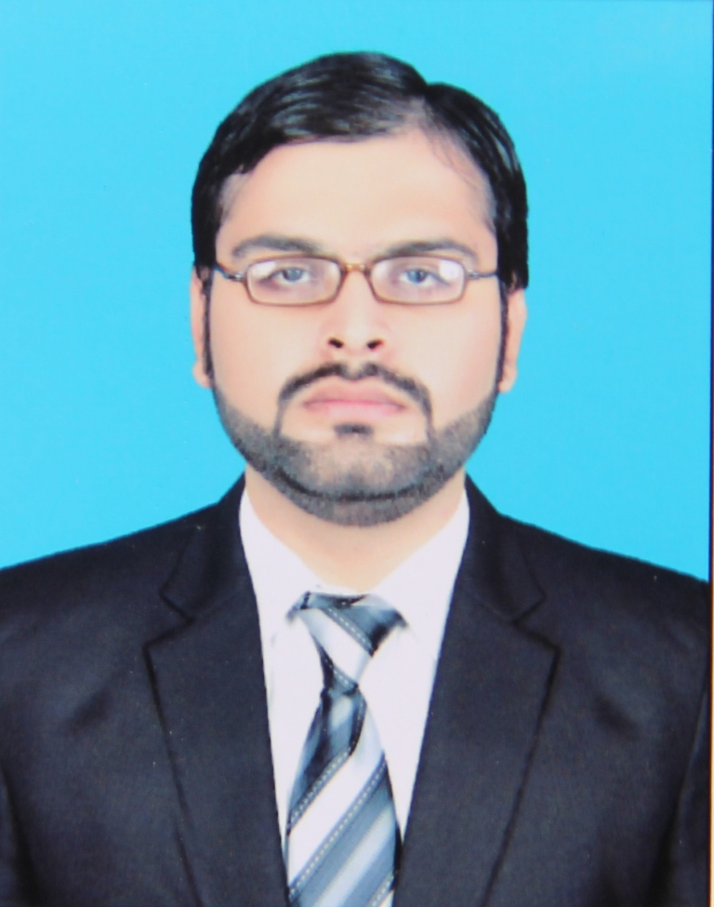

R**ESUME**

|  |
| --- |
| **IFTIKHAR HUSSAIN** |

|  |
| --- |
| **Personal Profile** |

***Father’s Name:*** Intesar hussain  ***Date of Birth:*** 06th April 1993.

***N.I.C #*** 45501-9351847-9 ***Nationality:*** Pakistani

***Religion:*** Islam  ***Marital Status:*** Single

***Address:*** Al-raza house opposite ogdcl office piran ghaib road multan.

***Cell:*** +923366382606 **Email:** iftikhar.hussain001@yahoo.com

|  |
| --- |
| **Professional profile** |

A dedicated and results-driven person with a supportable background. Possesses excellent interpersonal, communication and negotiation skills and the ability to develop and maintain mutually beneficial internal and external relationships. Enjoys being part of, as well as managing, motivating and training, a successful and productive team, and thrives in highly pressurised and challenging working environments.

|  |
| --- |
| **Academic Qualification** |

|  |  |  |  |  |
| --- | --- | --- | --- | --- |
| ***Degree***  ***Programs*** | ***Year*** | ***Marks/***  ***CGPA*** | ***Board/ University*** | ***Specialization/Subjects*** |
| BSc Chemical Engineering | 2011-2015 | 3.04 | NFC IET Multan | Chemical |
| FSc. | 2011 | 740/1100 | Govt.Emerson College bosan road, Multan | Pre. Engineering |
| Matric | 2008 | 600/850 | Saint Joseph Grammer School Multan. | Science |

|  |
| --- |
| **Experience** |

* One year internship at NFC IET MULTAN.

|  |
| --- |
| **Skills & Abilities** |

* Interpersonal and analytical skills.
* Hardworking, sincere, dedicated and very optimistic.
* Excellent oral and written correspondence with an exceptional attention to detail.
* Highly organized with a creative flair for project work.
* Ability to work in a fast-paced environment to set deadline.

|  |
| --- |
| **PEC NO** |

* CHEM/14069

|  |
| --- |
| **IT Skills** |

* Microsoft XP applications (Word, Excel, Office, PowerPoint)
* AutoCAD, Web Designing, Matlab, CHEMCAD.
* Familiar with Windows XP, 7, 8 and iOS Operating Systems.

|  |
| --- |
| **Languages** |

* Urdu, English.

|  |
| --- |
| **Reference** |

* Will be furnished on demand.