**MUJAHID MEHMOOD JANJUA**

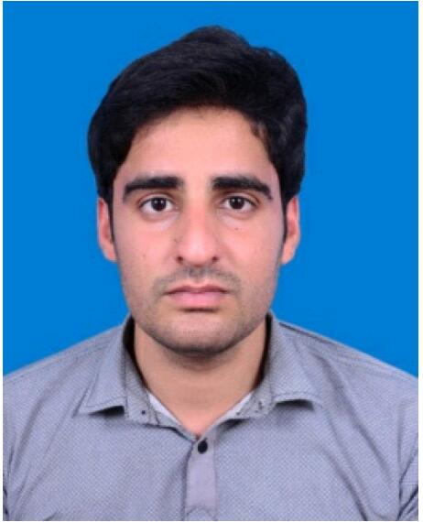

**Permanent address**: River view general store, Muhalla Sher zaman,

main Simly dam, road BharaKahu Islamabad.

Contact Number: Mobile: +923445904660

Email address: mujahid.mehmood128@gmail.com

**PROFESSIONAL** **OBJECTIVE:**

To pursue my career in an organization, where I can utilize my knowledge and experience to augment the fulfillment of organizational goals, and to be a valued member of my work team.

**PERSONAL** **INFORMATION:**

Father's name: Mehmood Hussain Date of birth: Aug, 24th, 1992

National Identity Card No. 61101-0476427-3

**ACADEMIC** **QUALIFICATIONS:**

|  |  |  |
| --- | --- | --- |
| **INSITUTE** | **YEAR** | **Grades** |
| University of Lahore (Islamabad campus) (ELECTRICAL ENGINEERING) | 2017 | A |
| PCC(Federal Board) HSSC  (pre-Engineering) | 2012 | A |
| (Federal board) SSC  (science-Group) | 2009 | A |

**QUALIFICATION** **YEAR** **OF** **PASSING**

**PROFESSIONAL** **EXPERIENCES:** **Internship:**

* Technology Innovators, (pvt) ltd. 2, block C2, street 97, G-

11/3, Islamabad 44000 Pakistan

* SUI NORTHERN GAS PIPELINES LIMITED, plot no 28-30, Industrial area I-9 Islamabad 44000

Pakistan

# STRENGTHS:

Good oral, interpersonal communication and presentation skills. Pleasant manners with a high sense of commitment, loyalty and patience. Highly adaptable to work in dynamic environment.

**OTHER** **Skills**:

* Computer skills:
* MS WORD
* MS EXCEL
* HARDWARE
* SOFTWARE

**LANGUAGES:**

English

Urdu

* Reference will surely be provided on demand.