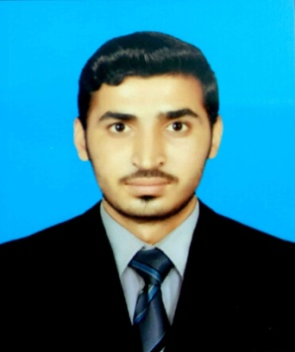BILAL HUSSAIN

Contact No: 0307-8004465

Email Address: bilalhussain.ryk14@gmail.com

Mailing Address: c/o Maqbool Ahmed, Chak # 86p, Post office Khas,

Sanipul, Tehsil & District Rahim Yar Khan.

**objective:**

Highly motivated to achieve a good position and work in a progressive organization where it should be provided with an environment of modernly equipped facilities so I can utilize my skills, abilities and qualification.

**Personal Profile:**

**Father Name: Maqbool Ahmed**

**CNIC No: 31303-5549849-1**

**Date of Birth: 03-02-1997**

**Place of Birth: Rahim Yar Khan**

**Domicile: Punjab**

**Nationality: Pakistani**

**Religion: Islam**

**Marital Status: Single**

**Postal Code: 64200**

**Academic Qualification:**

|  |  |  |  |  |  |  |
| --- | --- | --- | --- | --- | --- | --- |
| **DEGREE** | **YEAR** | **SUBJECT** | **BOARD** | **MARKS** | **PERCENTAGE** | **GRADE** |
| D.A.E 3rd  year | 2018 | ELECTRICAL | PBTE Lahore | 3145/3550 | 89% | A+ |
| D.A.E 2nd  year | 2017 | ELECTRICAL | PBTE Lahore | 2000/2250 | 89% | A+ |
| D.A.E 1st year | 2016 | ELECTRICAL | PBTE Lahore | 982/1100 | 90% | A+ |
| MATRIC | 2015 | SCIENCE | BISE Bahawalpur | 831/1100 | 76% | A |

**skill Development courses:**

* Six Months **Electrician** Course from NAVTTC
* Three Months **PLC** Course from PBTE/PSDF

**extra curricular activities:**

* Reading Books and Newspapers.
* Use Computer and Internet.
* Playing Cricket.

**Reference:**

* Will be providing on demand.