CURRICULUM VITAE

Abdul Ahad Khan

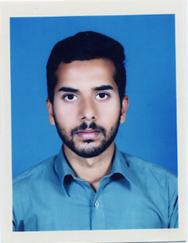House# 76, Ward No.17, Mohallah Malkanwala

Tehsil & District Bhakkar

Email:ahadkhan3866@gmail.com

Phone: 0336-6187247

CAREER OBJECT:

To achieve a suitable position in a dynamic organization offering career opportunities and allowing me to make significant contribution towards its success.

PERSONAL DATA:

**Father Name:** Muhammad Mumtaz Khan

**Date of Birth:** 15-01-2000

**C.N.I.C:** 38101-3903030-7

**Nationality:** Pakistani

**Marital status:** Single

**Religion:** Islam

ACADEMIC QUALIFICATIONS:

|  |  |  |  |  |  |
| --- | --- | --- | --- | --- | --- |
| **Examination** | **Institution/ Board** | **Session** | **Division / CGPA** | **TOTAL MARKS** | **OBTAIN MARKS** |
| S.S.C | BISE SARGODHA | 2013-2015 | 55% | 1100 | 605 |
| DAE (Electrical) | Punjab board of technical education Lahore | 2015-2018(11 September 2018) | 79.46% | 3550 | 2817 |

SKILLS:

* Communication
* Computer Operator
* Machine Operator
* MS Office
* Typing Speed
* Home wiring
* Public Dealing

HOBBIES:

* Study of Islamic Books
* Web browsing for latest research in technology
* Play cricket

REFERENCE:

Reference shall be provided demand