

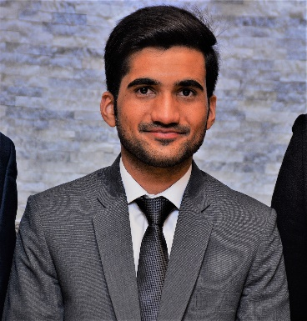

MUHAMMAD

USMAN

YASEEN



usmanyaseen2018@gmail.com

+923247687498

**OBJECTIVE**

My goal is to become associated with a company where I can utilize my skills and gain further experience while enhancing the company’s productivity and reputation.

**SKILLS**

* Pro Engineer
* MATLAB
* Microsoft Office



**PROJECTS**



* Tensile Testing Machine (FYP)
* Stapler Model In Pro-Engineer
* Design Of Chain Sprocket System
* Design Of Turbocharger



**EDUCATION**



|  |  |  |  |
| --- | --- | --- | --- |
| **DEGREE** | **GRADE** | **YEAR** | **INSTITUTION** |
| Matric | 84% | 2012 | Laboratory High School,  University Of Agriculture, Faisalabad. |
|  |  |  |  |
| F.Sc (Pre-Engineering) | 77% | 2014 | Punjab College Of Sciences, Faisalabad. |
|  |  |  |  |
| BS (Mechanical Engineering) | 2.7/4.0 (CGPA) | 2018 | Wah Engineering College, University of Wah, WahCantt. |



**EXPERIENCE**



* Four weeks internship at Pakistan Ordnance Factories.