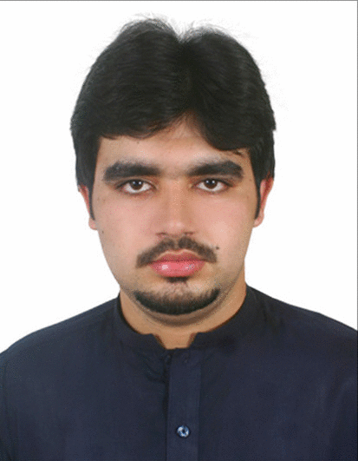

**SYED SAAD REHMAN**

**PAKISTAN**

**Cell # 0092-310-9870816**

**Email:[syed_rehman786@hotmail.com](mailto:syed_rehman786@hotmail.com)**

**OBJECTIVE**

To join a well reputed organization that offers me a stable and positive atmosphere to learn and implement new technologies for the betterment of the organization and inspires me to enhance my skills in the industry. Be part of a professional and competitive environment where i can expose my technical skills to the challenges of the practical world. Play an important role as a team worker and give the best in individual capacity.

**ACADEMIC QUALIFICATION**

|  |  |  |  |  |  |
| --- | --- | --- | --- | --- | --- |
| **QUALIFICATION** | **Subject** | **Year** | **Grades** | **CGPA** | **Board/University** |
| B.S. | Mechanical Engineering | 2017 |  | 3.41 | Ghulam Ishaq Khan Institute of Engineering Sciences & Technology |
| A-Level | Pre-Engineering | 2012 | 2-B’s, 1-C |  | Cambridge International Examinations |
| O-Level | Pure Sciences | 2010 | 3-A’s, 3-B’s, 2-C’s |  | Cambridge International Examinations |

**PROFESSIONAL EXPERIENCE:**

**Weatherford Oil Tools Ltd. Pakistan**

**Post Title** Trainee Logging Engineer

**Duty Location** Pakistan Petroleum Limited – Hub,Balochistan

**Period** January 2018 – PRESENT

**Responsibility**

* Collecting and preparing samples with a pre-determined sampling frequency from client.
* Measuring Shale Density when required and Calcimetry of samples collected.
* Annular and Pipe Volume, Lag and Down Strokes, theoretical calculation.
* Monitoring different drilling parameters.
* Making TGR and Trip-Sheet.
* Updating FWR charts, annexures under Mud Logger supervision.
* Assisting Pressure Engineer in Sensors/CVT installation or maintenance.

**Schlumberger Pakistan**

**Post Title** Internee

**Duty Location** Pakistan Petroleum Limited - Gujjar Khan, Punjab

**Period** August 2016 – August 2016

**Responsibility**

* Four weeks internship program.
* Exposed to different mechanical equipment installed at rig site.
* Assisted Chief Mechanic and his crew in maintenance of mud pumps, generators, centrifugal pumps.
* Was given chance to be part of the team overhauling Blow Out Preventor.

**Safety Courses**

* NEST (New Employee Safety Training; WITHOUT SIPP L2) NExT
* Occupational Health and Safety

**Technical Computational Skills**

* PTC Creo
* Ansys
* Comsol

**COMPUTER SKILLS**

* MS Office
* Emailing
* Internet

**PERSONAL DETAILS**

* **Passport No** DE9156182
* **Date of Birth** Novemeber 08, 1993
* **Nationality** Pakistani
* **Marital Status** Single
* **Languages** Pashto, Urdu, English
* **Address** House No. 29, Street 77, Sector E-11/2, Islamabad.

**References will be provided on request**