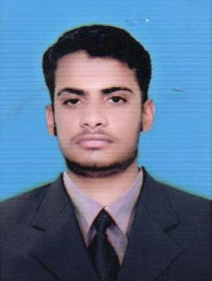

**MUHAMMAD IRFAN**

House # 122, 123-A Block Shah Rukn-e-Alam

Colony Multan.

Cell: 0301-8786856

Email: irfanfano555@gmail.com

***CAREER OBJECTIVE***

Seeking a job where I am able to implement my knowledge, experience & professional skills and demonstrate my strong commitment under a competitive and challenging environment.

***PERSONAL PROFILE***

**Father’s Name :** Muhammad Ramzan

**Date of Birth :** 12-11-1998

**C.N.I.C # :** 36303-8534044-1

**Marital status :** Single

**Religion :** Islam

**Domicile :** Multan (Punjab)

**Nationality :** Pakistani

***ACADEMIC QUALIFICATION***

|  |  |  |  |
| --- | --- | --- | --- |
| ***Degree*** | ***Year*** | ***Division*** | ***Board/School*** |
| **DAE (Chemical)** | 2018 | 1st | P.B.T.E Lahore |
| **Matric** | 2015 | 1st | B.I.S.E Multan |

***COMPUTER SKILLS***

* MS. Office (Word, Excel, PowerPoint)

***EXPERIENCE***

* Fresh

***LANGUAGES***

* Urdu, English, Punjabi & Saraiki

***INTERESTS:***

* Sports
* Social Media

***REFERENCE***

* Will be provided on demand