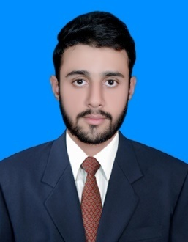**CURRICULUM VITAE**

**Ehsan Ilahi Alvi**

**Mobile: 923117110780**

**E-mail:** [ehsanalvi009@gmail.com](mailto:ehsanalvi009@gmail.com)

**Pakistan Engineering Council’s Registration No:14538/Chemical**

***Career Focus:***

Exceptionally focused and skilled chemical engineer with an outstanding customer satisfaction and safety record .Wide breadth of knowledge in industrial chemical process .Furnish clients with research, analysis and solutions optimizing operations, improving safety, strengthening compliance and capturing margin-improvement opportunities. Able to multitask effectively in handling high pressure and work situation.

***Experience:***

* Project Thesis on Production of Hexamine.
* Poster Presentation on Canadian Sand oils.

## ***Education History:***

**2010 Matriculation**

**BISE** － Multan, Pakistan

**1st Division 81%**

**2012 FSc. Pre Engineering**

**BISE** － Gujranwala, Pakistan

**1st Division 71% (Majors: Physic, Chemistry & Mathematics)**

**2016 BSc. Chemical Engineering**

**NFC Institute of Engineering and Technology －** Multan, Pakistan

**63%**

***Technical:***

Computer Skills  
Software: Microsoft Office, Matlab,Chemcad,Java ,C++,Primavera P6,Microsoft Word, Excel, PowerPoint,Internet research expertise.

***Strengths:***

* Well-developed skills in prioritizing, organization, self-motivated, believe in myself.
* Ability to work in any environment.
* Comfortable working in a fast paced, Challenging environment.
* I take full responsibility to work.
* Capable of delivering results based on critical thinking.
* Open to change and willing to learn new skills.
* Ability to follow up on pending issues.
* Logical and critical thinking.
* Active listening to minute details.
* Complex problem solving.
* Good inter-departmental coordination.

**Extra-curriculum activities:**

* Badminton, E-gaming
* Member of event organizing committee at NFC IET.
* Member of Arts and Literal Society at NFC IET.

***Personal Profile:***

**Name : Ehsan IIahi Alvi**

**Fathers Name : Ikhlas Alvi**

**Date of Birth : 29-09-1994**

**Nationality : Pakistani**

**Languages Known : English, Urdu**

**Reference will be provided on demand.**