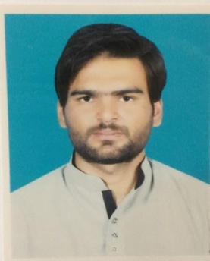**ABID SHEHZAD**

OBJECTIVE:

Accept and enjoy the new challenges and situation. Make a positive contribution towards the given situation, increase the wealth of the organization and enhance the knowledge, abilities and skills through organization by contribution.

PERSONAL BIO DATA:

Name : ABID SHEHZAD

Father Name : MUHAMMAD RAFIQUE

Cnic No : 37102-5421226-5

D-O-B : 03-10-1995

Religion : ISLAM

Nationality : PAKISTANI

Domicile : PUNJAB(ATTOCK)

Address : VILLAGE KOT BALA P.O. KOT FATEH KHAN ( TEHSILE FATEH JANG DISTT ATTOCK)

Email : abid83015@gmail.com

Contact No : 03060859406

QUALIFICATION:

|  |  |  |  |
| --- | --- | --- | --- |
| **DEGREE** | **YEAR** | **MARKS** | **BOARD** |
| **SSC(SCIENCE)** | **2013** | **516/1100** | **BISE,RWP** |
| **DAE(MECH)** | **2017** | **2396/3450** | **PBTE,LAHORE** |

**OTHER CERTIFICATES:**

* Basic Computer Course.
* CNC Turning Programe Course ( A Grade )
* **EXPERENCE:**
* 03 Years Apprenticship in Mechanical ( MACHINIST ).( 02-July-2018 & 02-July-2021).

**LAUNGAUGE:**

Effective and Efficient Writing Skills,Oral Communication Skills,Listening Skills in

* URDU [EXECELENT]
* ENGLISH [EXECELENT]

**Computer Comprehension Command On:**

* Operating System
* MS Office
* Installation of Software
* Internet
* Basic Hardwar

**PERSONAL ATTRIBUTES:**

* + Hardworking, Reliable and Dedicated.
  + A Self Motivated Individual.
  + Good Communication and People Oriented Skills.
  + An Eager and Quick Learner.
  + An Organized Person.

**REFERENCE: Reference will be provide on your demand.**