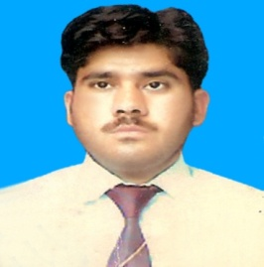

**Saddam Hussain**

**S/O Izat khan**

**PERMANENT ADDRESS______________________________________**

Mohallah jameel abad, P.o Hassan abdal, wah cantt.

E-mail:saddamwec@gmail.com

Mob: ­+92 3155406156

**OBJECTIVES_________________________________________________**

To pursue a challenging and illustrious career in a progressive and congenial environment to utilize my diligence and technical abilities to their peak and quench my thirst for knowledge and experience making me triumphant in quest of excellence in field and contributing to company's benefit.

**EDUCATION ___**

* **BSc in Chemical Engineering** (2010-2014)

**University of wah , wah cantt, Pakistan**

**CGPA** 2.52/4.00

**Final Year Project**: Design and fabrication of Lab scale equipment for the production of Gasoline from Naphtha,and finding optimum parameters.

* **Intermediate in Pre Engineering** (2008-2010)

Tamer e seerat School and collage, swabi, Pakistan.

**Result:** 64%(Distinction)

* **Matriculation in Science group** (2008)

Govt High school jalsai, swabi, Pakistan

**Result:** 73% (Distinction)

* **Diploma of information Technology**

**Result**: 77%

**INTERNSHIPS___________________________________________________________________*_***

* Pakistan ordnance factory wah cantt (4 weak)
* QC Engineer at Dewan cement limited,(6 months)
* QC Engineer at Coronets foods (pvt) limited (1year)
* Trainee Engineer at China petroleum corporation( pvt) limited (1Year)

**COMPUTER SKILL ____________________**

* Microsoft Office
* Matlab
* Auto CAD
* Coral draw
* Intenet

**LANGUAGES_______________________________________________________ ______________**

* English, Urdu, Pashto (Read, Write & Speak)

**AWARDS AND ACHIEVEMENTS___________________________ ________________________**

* 1st Position in School in the S.S.C Examination
* 1st Position in DOST Project poster Exhibition
* First positiom in Project exhibition arranged by PEC, UW and PASTIC

**PARTICIPATIONS______________________________________________________________________**

* Participated in Directorate of sciene and technology(DOST) seminar at PCSIR, wah cantt.
* Participated in Seminar on Communication and Presentation skills Training Session by Schlumberger