***ARSLAN KHALID***

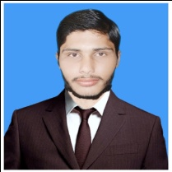 *House no#19, Street no#02, Main Oil Agency Street, Shah Jewan Colony, Girja Road, Chak Jalal Deen, Rawalpindi*

*0303-5342848*

*******arslankhalid4246@gmail.com*

***OBJECTIVE***

*To apply professional and academic knowledge in challenging environment of the organization and advancement.*

***PERSONAL INFORMATION***

* ***Father’s Name :*** *Khalid Mehmood*
* ***Date of Birth :*** *22 Nov, 1995*
* ***CNIC No. :*** *37405-8114461-5*
* ***Religion :*** *Islam*
* ***Nationality :*** *Pakistani*
* ***Gender :*** *Male*
* ***Marital Status :***  *Single*
* ***Domicile :*** *Rawalpindi, Punjab*

***ACADEMIC QUALIFICATION***

|  |  |  |  |  |
| --- | --- | --- | --- | --- |
| ***Degree/Cert*** | ***Marks*** | ***%age*** | ***Year*** | ***Board/University*** |
| *Matric (Science)* | *549/1050* | *52%* | *2012* | *FBISE* |
| *DAE (Mechanical)* | *2618/3450* | *75%* | *2016* | *PBTE* |

***LANGUAGE CAPABILITY***

* ***English, Urdu, Punjabi***

***HOBBIES***

* ***Net Suffering, Reading Islamic Books***

***REFERENCE***

*Reference will be provided on demand*