***m Abu bakar*** 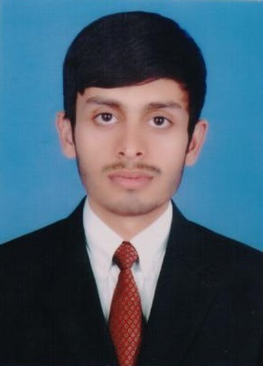

***Address: House No # 47 Near Saeed karyana Store Habib colony Sheikhupura***

***Mobile #: +92-0324-4358800***

***objective***

Pursuing a position as a responsible team member in successful organization to develop and fully utilize my skills in a productive environment and obtain a position in a dynamic company that will utilize my talent and abilities, with room for advancement while gaining valuable experience in the corporate surroundings.

***personal informations***

* *Name : M Abu Bakar*
* *Father’s Name : Rana Sarfraz Arshad*
* *Date of Birth : 11-01-1997*
* *CNIC : 35404-7244161-5*
* *Domicile : sheikhupura (Punjab)*
* *Religion : Islam*
* *Marital Status : Single*
* *Gender : Male*
* *Nationality : Pakistani*

***Qualification***

* ***Matric***

*I have done my Matric with 435/1050 from BISE Lahore* ***2012***

* ***D.A.E (Electrical)***

*I have done my D.A.E (Electrical ) with 2754/3550 from PBTE Lahore* ***2013***

***. B.sc***

*Doing B.sc Electrical Engneering Technology From G.C.T Samnabad FSD Affiliated With U.E.T Lahore…..*

***Others Skills***

* *MS Office*
* *Windows*
* *Internet*

***Language***

* *English*
* *Urdu*
* *Punjabi*

***Reference***

* *Will be furnished on demand.*