**My Resume**

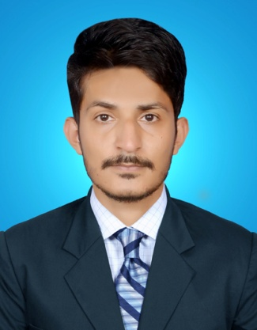**UMAR YASEEN**

**S/O MUHAMMAD YASEEN**

**Address:** House # 494/B, Chak # 66 JB, Dhandra,

Jang Road, Faisalabad.

0313-6693866

0300-6610766

OBJECTIVE

**An Excellent Skilled Engineer** to secure a career in a reputed organization, which appreciates professional approach and hard work, where I can utilize my knowledge and various skills in contributing towards fulfilling the organization’s growth, objectives and to develop my career.

PERSONAL INFO

**Nationality** PAKISTANI

**Date of Birth** 02/07/1992

**National ID Card Number** 33103-8828119-7

**Religion**  ISLAM

**Domicile**  FAISALABAD

**Email ID** umaryaseen66@gmail.com

ACADEMIC QUALIFICATION

* **Bachelor of Science in Electrical Engineering (CGPA: 3.8/4.0)** (2018)

**Institution:** University of Lahore, Islamabad Campus

(Accredited with Pakistan Engineering Council)

* **Diploma Of Associate Engineer in Electrical Technology** (2012)

**Institution:** Govt. College of Technology Faisalabad

(Punjab Board of Technical Education Lahore)

* **Matriculation(Science Group)** (2009)

**Institution:** Govt. MC High School Faisalabad

(Board of Intermediate & Secondary Education Faisalabad)

COMPUTER SKILLS

**Can Work On**

Matlab, AutoCAD, Pspice, Arduino, Protius, PLC

MS (WORD, EXCEL, POWERPOINT)

INTERNET SURFING

EMAIL USAGE

And many other Software’s

PROFESSIONAL EXPERIENCE

* **Indus Home Pvt. Ltd** (Nov 2012 to May 2014)

**Duration:** 1.5 Year

**Designation:** Electrical Maintenance Operator

INTERNSHIP

* **PESCO**

**Duration:** 8 Weeks

TECHNICAL SKILLS

* **Tevta Special Training Program**

Milling Machine Operator

**Duration:** 4 Months

LANGUAGE

Excellent Communication Skills and Fluency in **Languages**

* English
* Urdu
* Punjabi