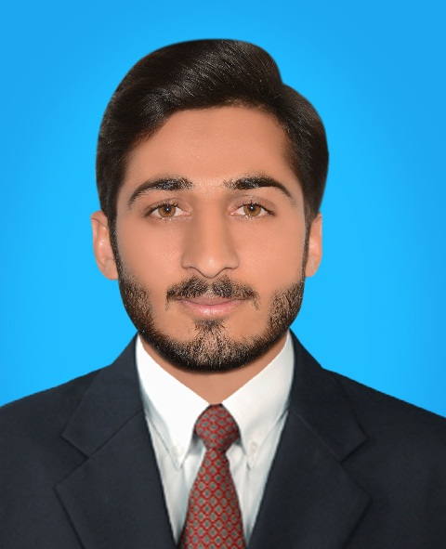

**SHAHID HUSSAIN**

**Bachelor in Chemical Engineering**

**Production of electricity from Rice Husk through Gasification.**

* A good start up to minimizes the cellulosic waste and almost reduce fall down of electricity in our country.

**FINAL YEAR PROJECT**

**Internee Engineer at** DG Khan Cement Company limited, kallar kahar Chakwal district Punjab.

**Understanding Process**:

Applied my technical knowledge to get through deeper insight of cement process, understood the working of crushers, hoppers and elevators.

**WORK EXPERIENCE**

**Bachelors in Chemical Engineering (2014 – 2018)**

From: University of Engineering and Technology

Lahore, Faisalabad Campus.

CGPA: 3.143

**HSSC & SSC**

From: Misali Higher Secondary School

District Muzaffar Garh

**Intermediate**: 2011–2013.Grade Achieved: A

**Matric**: 2009 – 2011. Grade Achieved: A+

**EDUCATION**

**Basic Understanding of**: AutoCAD, Mat lab, Aspen Plus.

**Sound Knowledge of**: Microsoft Office (Word, Excel, PowerPoint).

**Basic Understanding of:** Drawing PFD in Microsoft Visio.

**TECHNICAL SKILLS**

Cricket, Badminton, Volleyball and computer games.

Reading Technical Magazines and research papers.

Attending Technical Seminars and Workshops

**🌎** linkedin.com/in/shahidhussainray

**🖂** ShahidHussain00079@gmail.com

**✆** +923012938079

**🏠** Telenor Franchise, Chowk Sarwar Shaheed

District Muzaffar Garh, Pakistan

**Contact**

Seeking opportunity to work as Chemical Engineer in renowned organization where I can practically apply and improve my Technical and Managerial skills acquired from my education and continuously extend my education, add value to the system and Grow with the organization.

**CAREER OBJECTIVE**

**Extra-curricular Activities**