## CURRICULUM VITAE

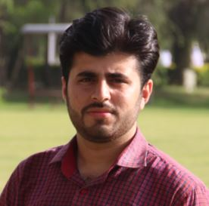

**Objectives:**

I am seeking an Organization where I can use my education to help the company meet and surpass its goals. I am very keen learner and have the ability to work under pressure and tough situations.

**Educational Qualifications:** Matric (Science)

Garrison Cadet College Kohat, (2010-2012)

Intermediate (Pre Eng.)

Garrison Cadet College Kohat, (2012-2014)

**Bachelor of Electrical Engineering(Power)**

**Air University Islamabad, (2014-2018)**

**Final Year Project: Wireless Power Transmission**

This Project is used to charge a mobile without any conducting wires. The Module is designed very economical. The DC input (12V) is boosted up and converted to high frequency Oscillations which are fed to the transmitter coil and then received by receiver coil. The transmitted voltages are then rectified and fed to the load.

**Semester Projects: Density Based Traffic Control System.**

**Single Phase to 3 Phase converter using 8051.**

**Designing & Implementation of Audio Amplifier.**

**Railway Detection System.**

**Emergency Light.**

**Designing and making Transformer and DC motor.**

**Computer Skills:** Microsoft Office (Word, Power Point, Excel)

Windows, Email etc

Computer programming (C++)

**Softwares:** Matlab, Proteus, Packet tracer, Altium Designer, MikroC Pro, Keil

**Language Skills:** English

Urdu

Punjabi

**Personal Abilities:** Good Analytical and communication skills.

Passion for hard work.

Ready to take initiative.

Ability to work in a stressful environment.

**Personal Details:**

* Name : Waseem Abbas
* Nationality : Pakistani
* Date of Birth : 05/09/1995

Present Address : Village Saidra Khurd & P.O Ahmal Pur, Tehsil & District Sialkot

* Passport No : NX1010661, Exp: June-2022
* Cell # : +92 3426850072 / +92 331858841
* Email : 03426850072waseem@gmail.com
* Driving Licence : Pakistan