**Curriculum Vitae**

**Kafayat Ullah**

Address:

Mohallah Muhammad Nagar Street No 3 House No CB 190 Attock cantt.

**Contact: 0306-0848466**

**Personal Information**

Father’s Name:

**Faizullah**

D.O.B:

**15-10-1995**

CNIC #:

**37101-4284310-7**

Domicile:

**Punjab (Attok)**

Religion:

**Islam**

Marital Status:

**Single**

Permanent Address:

**As Above**

Nationality:

**Pakistani**

Language:

**English, Urdu,Punjabi**

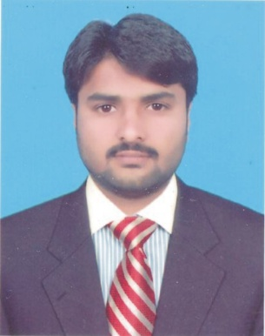

**AS AN ASSOCIATE ENGINEERING**

To serve an organization that utilizes my potential in the best way and would help to serve my community as well as provide an opportunity to improve my skill and knowledge. So, I can learn and apply innovative ideas and excel my career.

Matric (Science) 640/1050 FBISE (Islambad)

[2012]

DAE(Mechanical) 2354/3450 PBTE(Lahore)

[2015]

* Computer skills, Internet (browsing ), Ms word
* Will be Provided on demand.
* Apprenticeship in PAC Karma (06 Months Machinist)
* CNC Vertical lathe Machine (Operator)
* Internship in PAC Kamra ( 01 year)