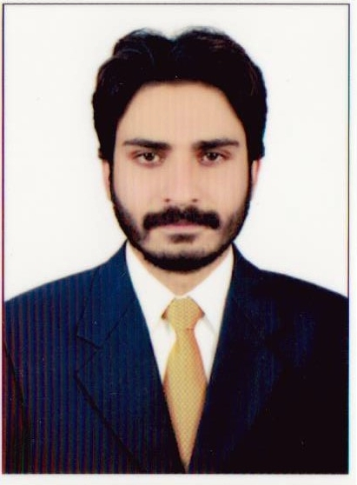**Muhammad Junaid Khan**

**ELECTRICAL ENGINEER**

House No S7 # 30 H.I.T Colony Taxila Cantt | 03065880782 | [khanjunaid675@gmail.com](mailto:khanjunaid675@gmail.com)

 DOB:26-MAR-1995

Summary



To work in a firm with a professional work driven environment where I can utilize and apply my knowledge, skills which would enable me as a fresh graduate to grow while fulfilling organizational goals.

Education



|  |  |
| --- | --- |
| **2013 – 2017** | **Bachelor of electrical engineering** |
|  | University of science and technology Bannu |
|  | CGPA 3.34/ 4.0 |
|  | 83.5% |

|  |  |
| --- | --- |
| **2011 – 2013** | **FSC** |
|  | F.G Degree college for Men Wah Cantt |
|  | Pre-engineering |
|  | Marks 810/1100 |
|  | 73.63% |

|  |  |
| --- | --- |
| **2009 – 2011** | **Matric** |
|  | F.G Public high school Taxila Cantt |
|  | Science |
|  | Marks 864/1050 |
|  | 82% |
| Work experience |  |
|  |  |

|  |  |
| --- | --- |
| **July 2016 - Sep 2016** | **Internee** |
|  | **Heavy industries taxila** |
|  | • Basic Function of Tanks |
|  | • Electrical components of AL-KHALID |
|  | • Gun control unit |
|  | • Fire control system |
|  | • Auto loading system |
| Final year project |  |
|  |  |

**Simulation of Hybrid power system using solar and wind energy with integrated WAPDA using MATLAB.**

We designed a solar panel using equations obtained from circuit diagrams.We also design a wind turbine generating a specific power. And then WAPDA is integrated with them.

Major courses studied



* Control Systems
* Electric circuit analysis
* Electronics 1&2
* Electrical Measurements and Instrumentation
* Electric Machines
* Digital logic Design
* Data Communications & networks
* Signals & Systems
* (DSP)Digital Signal processing
* Communication systems
* Wireless communication
* Optical fiber communication
* Telecom transmission and switching

Computer Skills



MS Office (Word, PowerPoint, Excel, Outlook),

Matlab

Multisim

Autocad

Software installation

Internet browsing

Languages





English



Urdu



Pashto

Personal skills Interest



* Punctual of Time Travelling
* Hard worker Reading
* Good communication skill photography
* Quick learner

Refrences



Further Refrences will be provided when requested.