Hassan Mustafa 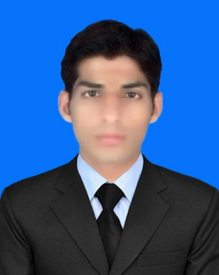

[eng.hassan.syed@gmail.com](mailto:eng.hassan.syed@gmail.com)

+92 302 8760969

Ward No.1 Mohala Jam wala

Near Garrison Public School Kot Sultan district Layyah.

**Objective:**

To be Researcher in an organization where I can get substantial practical exposure to justify my theoretical knowledge and improve my technical skills beyond the needs of a dynamic and reputable organization.

**Education:**

|  |  |  |  |
| --- | --- | --- | --- |
| **Year** | **Degree** | **Obtain/Total** | **Board/University** |
| 2012-2016 | B.Sc. Chemical Engineering | 3.23CGPA | **Institute of chemical Engineering & Technology (I.C.E.T.)**  **University of the Punjab Lahore.** |
| 2010-2012 | B.Sc. Chemistry | 64.75% | **BAHAUDDIN ZAKARIYA UNIVERSITY,MULTAN** |
| 2008-2010 | F.sc | 72% | **Board of Intermediate & Secondary Education,D.G Khan** |
| 2006-2008 | Matric | 68.11% | **Board of Intermediate & Secondary Education,D.G Khan** |

**Achievements:**

* Remained Class Representative due to distinction during college.
* Submitted all the assignments on time during engineering studies until now.
* In B.sc I got 1st position in my college.

**Languages:**

Good in speaking, reading and writing **English** and **Urdu**. Also having good understanding of **Punjabi**, **Hindko** and **Saraiki**.

**Technical Skills:**

* MS Office
* Mat Lab
* AutoCAD
* Camcad

Process Report:

**Oct 2015 – Jan 2016**  **A Process Report On The Preparation Of shampoo**

Final Year Project:

**Production of hydrogen from ethanol**

Internship:

**June 4 – July 2, 2016 Four weeks in Pakistan steel Mill Karachi**

Interest:

**Reading Soccer Movies** **and** **Documentaries**

Refrance:

Reference will be furnished on demand.