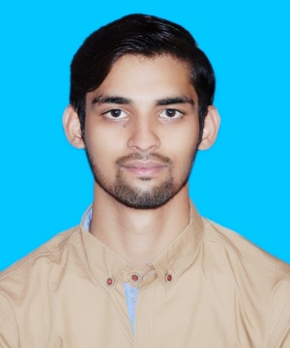

M. SAYYAM

HVAC & R ENGINEER

Phone: +92-335-4161916

EMAIL:Sayyammughal322@gmail.com

Address:House No. 6 Al-Khan Hotel Imran Street Sheikhupura Road Lahore

**OBJECTIVE**

Looking for a challenging position in a reputable organization, having an attractive environment, and prospects of growth and learning. Being a young and energetic person I can accept the challenges as a team member and as leader of the team.

**EXPRIENCE**

**PAKISTAN RAILWAYS**

* Carriage & Wagon Shop in RAC Department
* Duration (2-Months)

**PAK ELEKTRON LIMITED**

* AC Split Department
* Duration (1-Month)

**PRIVATE SHOP**

* Split AC & Refrigerator
* Duration (2-Months)

**PROFESSIONAL COURSE**

English Communication & Personality Grooming

* Govt. College of Technology Railway Road, Lahore

**PERSONAL ATTRIBUTES**

* Good Communication Skill
* Good Listener
* Self-Motivated
* Responsible

**HOBBIES**

* Cricket
* Badminton
* Internet & Movies

**REFERENCE**

Will be furnished on demand.

**EDUCATION**

Govt, College of Technology Railway Road, Lahore

* DAE Mechanical (With Specialization in Heat Ventilation, Air Conditioning & Refrigeration)
* 70.8% Marks
* Session (2015-2018)

Govt. High School, Shahdara Lahore

* Metriculation
* 63.4% Marks
* Session (2013-2015)

**COMPUTER SKILLS**

* MS WORD



* MS EXCEL



* INPAGE URDU

