## **TALHA ZAHOOR**

**Curriculum Vitae**

**Address:** Village Pushtoon Garhi P/O & Tehsil Pabbi District Nowshera.

**Contact #:** 0092-313-0425016

## 1dabbi **OBJECTIVE:**

To work in a challenging environment in any government and non-government organization for career growth through sincere, achievement and skill and where evaluation is based on performance and where is an equal chance of career development.

## dabbi **PERSONAL INFORMATION:**

* 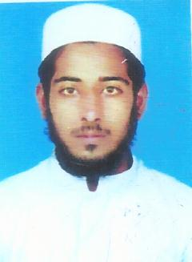Name : Talha Zahoor
* Father’s Name : Zahoor Khan
* Nationality : Pakistani
* Date of Birth : 10-03-1997
* CNIC : 17201-8364306-1
* Religion : Islam
* Domicile : Nowshera KPK Pakistan.
* Gender : Male
* Marital Status : Single

dabbi **EDUCATIONAL INFORMATION:**

|  |  |  |  |  |
| --- | --- | --- | --- | --- |
| **DEGREE** | **YEAR** | **MARKS OBTAINED** | **TOTAL MARKS** | **BOARD** |
| S.S.C | 2014 | 640 | 1100 | BISE Mardan |
| D.A.E (Electrical) | 2017 | 2348 | 3550 | BTE Peshawar |
| B.A | Continue |  |  | Uni of Peshawar |

dabbi **Islamic Qualification:**

* Khafiz Ul Quran

dabbi **Hobbies :**

* **Volleyball**
* **Cricket**

dabbi **LANGUAGES:**

* English
* Urdu
* Pashto