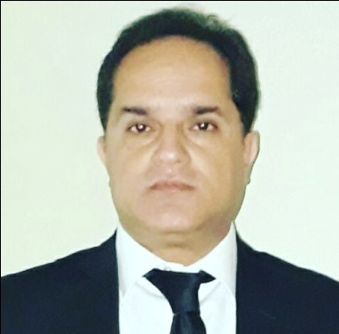***Mohammad SaLEEm Baloch***

***Advocate High court Pakistan Lahore***

***Contact: 0321-4898262***

***E-mail:*** [***saleembalochadvocate@gmail.com***](mailto:saleembalochadvocate@gmail.com)

|  |
| --- |
| ***Personal Information:*** |

* Father's Name : Haji Abdul Majeed
* Date of Birth : 01-06-1970
* Marital Status : Married
* Nationality : Pakistani
* Religion : Islam
* NIC : 35202-7371933-1
* Permanent Address : House # 228/C, Punjab Govt Employees Housing Society Phase 2, Lahore

|  |
| --- |
| ***Professional Profile*** |

* More then 14 years vast and rich experience of Corporate and Criminal law.
* I have given my successful legal services to the biggest Group of Companies.
* Solving all kind of Legal litigation and look for permanent solutions.

|  |
| --- |
| ***LEGAL sPECIALITIES*** |

* Criminal litigation
* Court Matters
* Debt Recovery
* Govt Affairs
* Police matters
* FIA
* Property matters
* Labour court
* Trade Mark
* Facilitate and solve Custom, FBR and Tribunals
* Good Relations with Higher Govt Officials

|  |
| --- |
| ***Skills*** |

* Knowledge of Microsoft Office (word, excel, power point).
* Confident and Neutral Accent of English.
* Excellent interpersonal, report writing, negotiation, and communication skills.
* Good at solving problems and able to think critically on different legal issues.

|  |
| --- |
| ***Experience*** |

**Member Lahore High Court**

Owner at S.B Law Associates Pakistan Lahore

Mar 2007 - continue

**Legal Advisor**

Marvel Paint Industries Lahore

Jun 2018- continue

**Litigation Attorney**

Treet Group of Companies Lahore.

Feb 2018 to continue

**Legal Counsel**

Tufail Chemical Industries Karachi

March 2015 to continue

**Legal Advisor**

Alka Chemicals (Pvt) Ltd Faisalabad

May 2009 – Jan 2014

**Legal Advisor** Ali Akbar GroupLahore June - 2006 –March 2009

**Legal & Debt Recovery Officer**

Sitara Chemical Industries / Sitara Textile Faisalabad

March 2004 - May 2006

|  |
| --- |
| ***Qualifiation*** |

* + LL.B 1996-1998 University of Karachi
  + B.A 1994 University of karachi