**Curriculum Vitae**                 

: 0321-6863747

E-mail:Shani_Shan44@yahoo.com

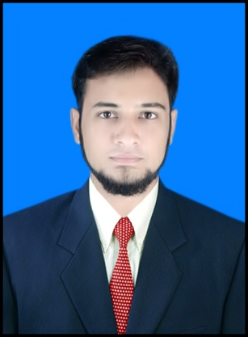

ZEESHAN SHAFI 

Dasti Avenue, Near General Bus Stand

*Distt. Muzaffargarh, Punjab Pakistan*.

|  |
| --- |
| ***PERSONAL INFORMATION:*** |

1 Father’s Name : Rai Muhammad Shafi

2 Date Of Birth : 18-09-1993

3 Religion Islam

4 Gender Male

5 Marital Status Single

6 Nationality : Pakistani

7 NIC # : 32304-1772809-7

8 Domicile : Muzaffargarh, Punjab (Pakistan)

|  |
| --- |
| ***OBJECTIVE:*** |

To utilize my expertise in the field of electrical engineering and implement my innovative

Ideas and creative mind towards the area of specialization.

|  |
| --- |
| ***EDUCATION:*** |

**B.Sc ELECTRICAL (POWER) ENGINEERING:** (2016)

(CGPA 3.17/4.00)

ISLAMIA UNIVERSITY OF BAHAWALPUR

Registered Engineer through Pakistan Engineering Council with Reg.No:ELECT/57692

**Intermediate:** (2012) (81.27%) (**1**st division) D.G.Khan boad.

**Matriculation:** (2009) (76.57%) (**1**st division) D.G.Khan board.

|  |
| --- |
| ***COMPUTER SKILLS:*** |

* Sound knowledge of;

Computer, Internet & MS Office.

* To Complete the Data Entry Job of each property Unit in Accordance with the guidelines and training provided.
* Diploma of AUTOCAD
* Proficient in various apparatus and technology which

is being used in modern era.

|  |
| --- |
| ***EXPERIENCE &OTHER SKILLS:*** |

* As Trainee Electrical Engineer at **THERMAL POWER STATION** Muzaffargarh.
* A dynamic team member, able to bring energy, enthusiasm, in team.
* Ability to work alone or as part of a team.
* Motivate team members to achieve potential and meet organizational objectives.
* Time Management Skills.
* Problem Identification & Solving Skills.
* Good communication and interpersonal skills.
* Team working and leadership skills.
* Last but not the least, I am proud to offer honesty & loyalty.