MUHAMMAD MEHRAN HASHMI

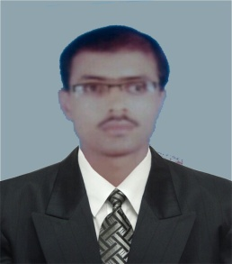

Mobile #: 03069058876

E-mail: [mehranhashmi13@gmail.com](mailto:mehranhashmi13@gmail.com)

**Current city**: Mianwali

**CAREER OBJECTIVE:**

To have a growth oriented and challenging career, where I can contribute my knowledge and skills to the organization and enhance my experience through continuous leading and teamwork.

**Qualification:**

|  |  |  |  |  |
| --- | --- | --- | --- | --- |
| COURSE | INSTITUTION | BOARD/UNIVERSITY | PERCENTAGE/CGPA | YEAR OF PASSING |
| B.Sc. Mechanical Engineering Technology | Dr. A.Q Khan Institute of Technology Mianwali | UET Lahore | CGPA: 2.815 | 2018 |
| DAE Mechanical Technology | Dr. A.Q Khan Institute of Technology Mianwali | PBTE Lahore | 76.09% | 2013 |
| SSC | PAEC Boys College Chashma (Mianwali) | Fedral Board |  | 2010 |

**Academic project:**

1. **Hydraulic Crane:** Designing and manufacturing the working model of Hydraulic Crane.
2. **Hydrogen Production by Electrolysis:** solar energy use for electrolysis process.

**Software skills:**

1. Ms Office
2. Cnc simulator for turning center

|  |
| --- |
| **Languages:** Language: English [Average] Language: Urdu [Excellent] |

**Hobbies:**

2. Playing cricket, Badminton

**Personal Information**

father name: nasar ul haq hashmi

Contact #: 0306-9058876

**Permanent Address**: Meli Peer Bkhash Tiba Qaim Din Tehsil and District khushab

**Temporary Address:** House # H-12 Chashlum colony, P/O Box Wapda colony Chashma  
 Barrage, District Mianwali