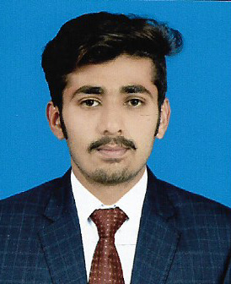

***OBJECTIVE :***

*To pursue a carrier in a dynamic and growing organization with a progressive*

*congenial and learning work environment where I can explode my technical and*

*management skills which I have acquired during my academic carrier.*

***PROFESSIONAL SUMMARY :***

*I have Experience in Machine Maintenance, Inspection, Quality Control and Best*

*Operating CNC Machine, Lathe Machine, Milling Machine, Shaper Machine, Power*

*Hacksaw and Other Machines. And also Expert in Electric Arc Welding, Spot Welding*

*Machine.*

***PERSONAL INFORMATION :***

***Father’s Name***  : Muhammad Nawaz

***Date of Birth***   : 30-11-1997

***CNIC***  : 38406-0468812-1

***Nationality***  : Pakistani

***Gender***  : Male

***Marital Status***  : Single

***Religion***  : Islam

***Domicile* :** Sargodha(Punjab)

***E-Mail Address* :** abdulrehman2673@gmail.com

***Current Address* :** Mohalla Shakrani MasjidMidh Ranjha,

Tehsil Kot Momin, District Sargodha.

***DEGREE-SEEKING EDUCATION :***

***2015-2018 Mechanical Associate Engineers (DAE****)*

**Hira Polytechnic College**

***Board*** **:** Punjab Board of Technical Education Lahore

***3rd Year*** **:** 3040/3450

***Ave* :**88.11%

***2012-2014 Matric***

**Govt.Higher Secondary School Midh Ranjha**

***Board***  **:** Bise Sargodha

***Obtained Marks*** **:** 663/1100

***Ave***  **:**  60.27%

***SUBJECT STUDIES :***

* Thermo Dynamics
* Machine Design
* Work Shop
* Hydraulic
* CAD-CAM

***OPERATING MACHINE :***

* Lathe Machine
* Milling Machine
* Shaper Machine
* Drill Machine
* Power Hacksaw

***WORK SHOP EXPERIENCE :***

* Boiler
* Engine Maintenance
* Compressor Maintenance
* Machine Maintenance

***SOFTWARE SKILLS :***

* Ms Word
* Ms Excel
* Ms Power Point
* Inpage (Urdu Composing)

***TECHNOLOGICAL PROFICIENCIES :***

* CNC programming
* CAD-CAM

***LANGAUGE :***

* Urdu
* Punjabi
* English

***ACTIVITIES :***

* Read the Function of Machine
* Maintain Machines
* Photography
* Reading the Newspaper
* Travelling
* Web Browsing
* Belize Mission :I try my best to help the helpless people

***REFERENCE :***

Reference will be furnished on demand.