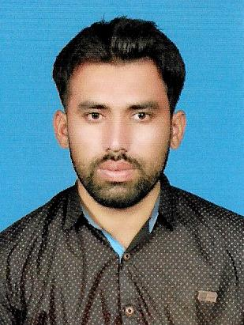Muzammil Javed

Cell # : 0315-6871559 , 0305-5469908

Email : [muzammiljaved51@gmail.com](mailto:muzammiljaved51@gmail.com)

Present Address : *street No 3 Mohulla Muhammad PuraDr.Maqsood Ahmad*

*HouseKoray wali Chungi Tehsil Kabirwala District Khanewal*

Postal Address : *ChowdhryKeryana Store KoraywaliChungiJhang Road*

*Kabirwala*

*Domicile : Khanewal*

POFESSIONAL CAREER OBJECTIVE:

My knowledge in this field will help me to solve any problem in this field. Moreover, my devotion towards the job will encourage me to carry any difficult tasks. I have the skills which will aid me to maintain a good relationship with clients and team members. My positive attitude will always keep me on the right track. My hardworking attitude will be useful for the development of the company.

ACADEMIC QUALIFICATION

|  |  |  |  |  |  |
| --- | --- | --- | --- | --- | --- |
| **Examination** | **Board** | **Institute** | **Year** | **Marks** | **Percentage** |
| DAE (Chemical) | Punjab Board of Technical Education Lahore | Govt. College of Technology Multan | 2014 | 2384/3400 | 70% |
| Matric (Science) | BISE Multan | Zakriya Public High School Kabirwala | 2011 | 715/1050 | 68% |

TECHNICAL TRAININGS

**Rafhan Maize Products Company Ltd. Faisalabad**

01-09-2016 to 31-08-2017

* 1 year Experience as a Trainee Plant Operator in Rafhan Maize Products Company Ltd. Faisalabad in Wet Starch Department from 01-09-2016 to 31-08-2017.
* Handling of Loading Arms
* Operate Wet Starch Unit
* Operate Dos lawer control system (Dosing & Dispensing)
* Audit Assigned areas and all safety critical devices on a daily basis.
* Assisting in writing SOP,s preparing checklist and mandatory procedure for the process plant area.
* Controlling and maintaining plant environment.
* 5 months experience as Plant Operator at Sapphire Fibers Ltd. Raiwind in Dyeing Department from 04-09-2017 to 19-01-2018.
* 6 months experience as Plant Operator at Style Textile Pvt.Ltd. Raiwind Road Industrial Area Manga Mandi Lahore in Dyes & Dispensing Department from 24-01-2018 till date.

STRONG AREAS

* Pumps
* Valves
* Heat exchanger
* Boiler area
* Distillation Column

SKILLS

* Work Permit Training (PTW) and its implementation
* Emergency Handling Protocol
* Standby Man training
* Vessel Entry Protocol
* Personal Protective equipment
* MS Office (Word, Excel, PowerPoint) and internet utilities

LANGUAGE

* English
* Urdu
* Punjabi

HOBBIES

* Use Computer
* Playing Cricket
* Reading Books

REFERENCES

* Will be furnished on demand

PERSONAL PROFILE

|  |  |
| --- | --- |
| Father’s Name | Javed Iqbal (Late) |
| Date of Birth | 02-11-1996 |
| NIC No. | 36102-2161559-1 |
| Religion | Islam |
| Nationality | Pakistani |
| Marital Status | Single |