**Curriculum Vitae**

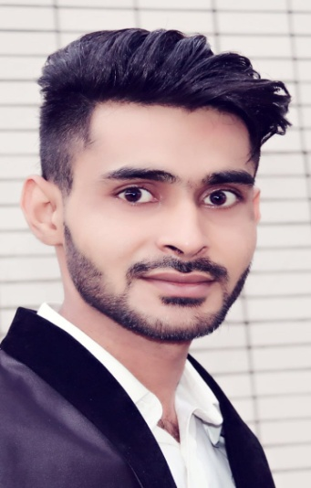Name: Syed Irfan Haider Naqvi

Gender: Male

Marital Status: Married

Profession: Civil Engineer

Date of Birth: 28.01.1994

Nationality: Pakistani

Address: Changsha University of Sciences & technology

Contact: +86-17775781244

Email: 3448856424@qq.com

**Objective:**

I am in a constant search of an environment where I can apply my skills with immense professionalism and precision, I want to prove myself worthy & express my skills in my field, if a chance is given to me in your well reputable organization.

**Academic Qualification:**

|  |  |  |
| --- | --- | --- |
| **Degree** | **Board/University** | **Year of Passing** |
| B.E(bachelor of Civil engineering) | Changsha university of science & technology, (China) | Jan-2018 |
| DAE 3 year diploma of Civil Engineering | SPI Gullan Khel (Pakistan) | 2011 |
| Diploma in Auto Cad | SPI Gullan Khel (Pakistan) | 2011 |
| Matriculation | Govt. High School Isa khel, Pakistan | 2008 |

**Language skills:**

* English, Chinese, Urdu, Hindi

**Computer related Skills:**

* Auto-CAD (Civil)
* 3D MAX (Civil)
* MIDAS (Civil)
* SAP2000 (Civil)

**Professional skills:**

* 29 months experience as sub engineer and architecture in GKG company Pakistan.

( from 15.08.2011 to15.02.2014)

* 3 months experience as a sub engineer in GKG Company Pakistan.

( from 18.12.2014 to 01.03.2015)

* 3 month experience as a architecture in GKG Company Pakistan.

( from 12.11.2015 to 01.03.2016)

* Personally working on AutoCAD since 2011. Designed some recent projects i.e. (worship place Buildings, College Buildings, Hospital Buildings and Specially Residential Buildings)
* Able to handle multiple tasks simultaneously, Effective communication skills ,Well organized, effective team player, Self-driven and target oriented.
* 