**SYED MUHAMMAD RAZA RIZVI**

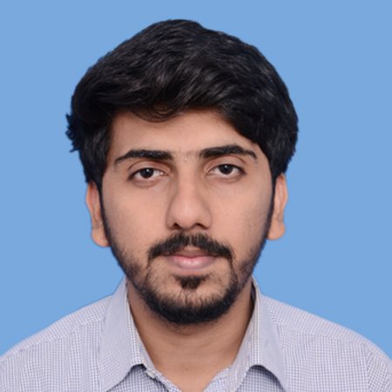

Address: House No: H-2 M.E.S Colony near PNS Shifa Hospital Defence Karachi.   
Cell phone: 0321-2905978 Email: engrraza18@gmail.com

Personal statement

My **focus** is to work for an organization that provides continuous learning environment so that I can make myself able to contribute in the success of organization.

Work Experience

**Service Engineer at Office Automation Group**

**DURATION: April 2018 - Present**

* Maintain good behaviour with client and proper work on machine to get full satisfaction of a client.
* Rectify the software, Network Problems, electronic control cards and electro mechanical faults of the printing system.
* Responsible to train customers on how to operate the machine to get the productive result.
* Installation and Maintenance of Konica Minolta digital printing press.

**Deputy Head of Technical Team at DAWOOD UNIVERSITY ROBOTIC CONTEST 2017**

**DURATION: 01-JUL-2017 to 30-NOV-2017**  
Being deputy head of technical team I was responsible to bring new theme based on the completion of several tasks and entertainment. I was also required to achieve the goals with the collaboration of my team.

* Interaction with students.
* Promoting technical aspects of several themes.
* Organizing workshops.
* Theme designing.
* Rules making and points Distribution.
* Solving technical problems

Industrial Automation Course

**Mindstorm Engineering**

**DURATION: June 2018 – Present**

* Working on different brands of PLCs such as Siemens, Delta and Fatek.
* Development of PLC logic program equipping with PLC/HMI according to requirements.
* Worked on VFDs, Pneumatics, PLC wiring and logic building.
* Controlling sensors included PT-100, optical and proximity sensor.

Internships

**Internship at FAUJI FERTILIZER COMPANY, GOTH MACHHI (FFC)**

**DURATION: JUNE-2017 to JULY-2017 (6 weeks Internship)**  
I have improved my technical and interpersonal skills and gained some valuable experience by working in several fields.

* Studied about the working principle of different measuring instruments.
* Learned about all several techniques used for measuring these process variables (Pressure, Temperature, Flow and Level).
* Worked in Field area and in Main Control Room where I learned about Distributed  
  control system and Emergency Shutdown.
* Studied about gas turbines, boilers, control valves, transmitters, switches, speed probes  
  and vibration probes.

**Internship at PAKISTAN TELECOMMUNICATION COMPANY LIMITED (PTCL)**

**DURATION: 26-DEC-2016 to 04-FEB-2017 (6 weeks Internship)**  
I have completed my 6 weeks’ internship in Operation and Switching Departments in which I have studied about different types of switching and worked on MSAG and MSAN. They trained us how to manage the faults.

Education

**Bachelors of Engineering | 2014 – 2018**

DAWOOD UNIVERSITY OF ENGINEERING AND TECHNOLOGY.

Major: Electronic | CGPA: 3.80

**Entrepreneurship for Engineers | 2016 - 2017**

INSTITUTE OF BUSINESS ADMINISTRATION (IBA)

Start-up: Fan-Ta-Stick, a company which provides cost effective and decorative solutions for household products like fan, refrigerator etc.

Key Skills

Programmable Logic Controller (PLC), VFDs, CISCO Packet Tracer, NI-LabVIEW, MATLAB, Circuit Simulation, Electronic Circuit Designing & Analysis, Entrepreneurial Skills, Programming, Communication, Creativity, Team work, Research and Development, Problem Solving.

Final Year Project

**Development and Implementation of VANET for Accident prevention and Traffic Regulation.**

* The system for this project uses three types of communication links, i.e. Vehicle-to-Vehicle (V2V), Vehicle-to-Infrastructure (V2I) and Infrastructure to Infrastructure (I2I).
* The project consists of two types of devices, a vehicle device and an infrastructure device.
* The vehicle device shares location, speed and direction data with other vehicles and infrastructure units. Infrastructure units also send this data to a Central Monitoring System for analysis.

**Awards and Achievements**

* Certificate for overwhelming performance in **Mock Interview** held at Dawood University of Engineering and Technology.
* Certificate of **MOS (Microsoft Office Specialist)** from Microsoft.
* Won the **BEST ALGORITHM AWARD** at SPEC’16 held at NED UET Karachi.
* **BEST SPIRIT OF PARTICIPATION AWARD** at NERC’16 held at NUST, EME college, Rawalpindi.

Other Projects

* Autonomous and Auto-Localizing Rescue Robot
* FM Transmitter and Receiver
* ECG Wearable Device with Monitoring on LabVIEW

Hobbies & Interests

Robotics, Graphic designing, Football