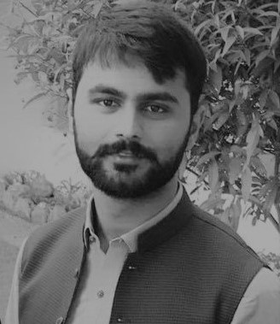 **SAQIB UR REHMAN**

Mandian comsats university, Abbottabad

House# 074, Street 2/5, Miskeen Abad#3 Peshawar City

+92 300 9350 297

saqibrehman62@gmail.com



**CAREER OBJECTIVE:**



To be associated with a promising organization which offers opportunities for professional and personal growth and where the potential is utilized for mutual benefit and committed to excellence.

**EDUCATION:**

|  |  |
| --- | --- |
| **Comsats University Islamabad (Abbottabad Campus)** | Abbottabad, Pakistan |
| Bachelor of Electrical Engineering (Computer) | 09.2014 –07.2018 |

|  |  |  |
| --- | --- | --- |
| **Government college Peshawar (GCP-Peshawar)** | Peshawar, Pakistan | |
| Pre-Engineering | 09.2011 – 06.2013 | |
| **Warsak Model School and College (WMSC-Peshawar)** | Peshawar, Pakistan | |
| Science | 03.2009 – 04.2011 | |
|  |  |  |
| **PROJECT LIST:**   * Digital clock **(DLD based concepts)** * EMF base voltage **generation (Basic Physics)** * Fire Alarm System **(circuit Analysis)** * Hostel Management System **(oop)** * Automatic Water Level detector **(Electronics)** * 220v-Ac to 12v-Dc amplifying to 48v-Dc * KUROKI implementation **(signals and Systems)** * Pitch controlling **(Digital Signal Processing)** * FM transmitter **(principles of communication)** * DC motor controlling **(electric machines)** * Local Area Network **(networking and communication)** * Motor controlling **(P, I, PI, PID techniques)** * Digital Security lock system **(micro-controller)** * Color bands on LCD**(FPGA-DSD)**   **FYP (SLAM using LIDAR Lite V3 for AGBOT-C1):**  **Features:**   * Robotics intelligent * Navigation System * Precise localization in urban environment |  |  |

**EXTRA CURRICULAR ACTIVITIES:**

**IT & Other Skills:**

* Proficient to work on MS Office (PowerPoint, Excel, Word).
* Excellent negotiation and communication skills gained through various seminars and workshop interactions.
* Quick learner, Good team player, good presentation and writing skills

**Languages:**

* English (Proficient), Pashto, Urdu (Proficient)

**Sports:**

* Part of high school Volley ball team and won state level Volley ball championship.
* Good in Boxing, Cricket and Badminton.

**Personal Interests:**

* Travelling, Cooking, Painting, Music, Exploring new people and cultures.

**GEOGRAPHICAL RESTRICTION:**

No preference.

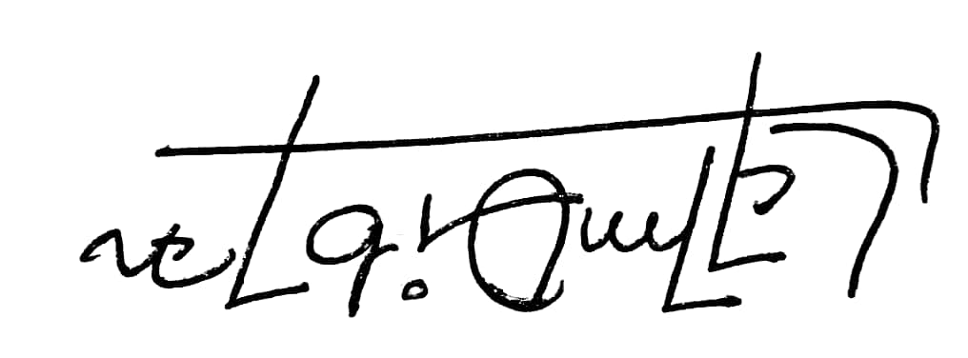

30. 07.2018