**ALI MURTAZA BABAR** 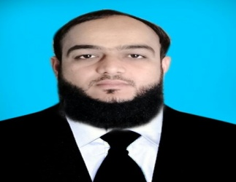

**Email**: [alimurtazababar@yahoo.com](mailto:alimurtazababar@yahoo.com) **Cell**: +923322792948 &+923147118464 **Address:** Mehran Tailor near Fish Market Road Dadu Sindh, Pakistan.

**Objective:**

My objective is to share my multi skills; work passion and team work with an Organization that Possess worth for these qualities. Candidate with in-depth knowledge about techniques.

**Qualification & Bio data:**

|  |  |  |  |
| --- | --- | --- | --- |
| **Year** | **Qualification** | **Division/GPA** | **Institution** |
| 2005-2007 | Intermediate (Pre-Engineering) | 1ST | BISE Hyderabad |
| 2003-2005 | Matriculation (Science) | 1ST | BISE Hyderabad |
| Date Of BIRTH | | 10TH Feb 1990 | |
| Nationality | | Pakistani | |
| Religion | | Islam | |
| Material Status | | Married | |
| Passport | | AN3025512 | |

**SKILLS & HSE KEY STENGHT**

I have good HSE Record. I have got many training Regarding Safety, Quality, Environmental, and Energy with Global Stander like ISO-9001-2008 ISO-18001-2007, and ISO-14001-2004.

* Permit to Work General Principles.
* Permit To Work Monitoring And Supervision
* Confined Space entry training and rescue
* Job Risk assessment, Toolbox Meetings & Take Timeout for Safety
* Plant Emergency Response
* Onshore Environmental Awareness
* Handling and Storage of Hazardous Substances
* Mechanical Isolation & Electrical Isolation - Extra Low & Low Voltage
* Portable Gas Detection - Selection, Challenging And Use
* Working on Height
* LO/LC isolation and procedure
* CBTA based competency enhancement system.
* CAT based competency enhancement system
* Critical Function Testing Operations
* Strong knowledge and experience in oil and gas production techniques
* Profound knowledge about safety precautions to be taken while handling inflammable liquids, gases and high pressure systems
* Proficient knowledge about the technical and mechanical aspects of the petroleum extraction procedures
* Possess the required physical fitness levels necessary to manage the physically enduring tasks Good communication skills, both oral and written
* Good Organizational skills and Good interpersonal behavior
* An Ability to work effectively with people across a wide range of level & responsibilities.
* Team working skills and the ability to maintain confidentiality
* Good Computer skills with wide operating skills in Maximo & 1SAP.