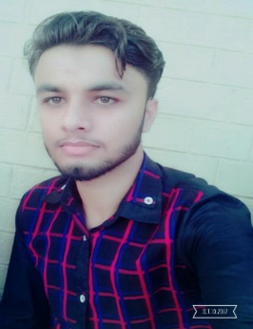

* **To Work in an organization as an integral part of it and accomplish the job assigned in a better way. I’ am looking for a highly challenging and dynamic work environment in which I will be able to enhance my professional skills and would be able to get valuable work experience.**

|  |  |
| --- | --- |
| * **Father Name** | **Syed Iftikhar Hussain Shah** |
| * **Date of Birth** | **01/07/1998** |
| * **CNIC: No** | **37404-0844042-3** |
| * **Nationality** | **Pakistani** |
| * **Gender** | **Male** |
| * **Religion** | **Islam** |
| * **Marital Status** | **Single** |
| * **Language** | **Urdu / English/Punjabi** |
| * **E-mail Address** | **Syedmohsinali550@gmail.com** |
| * **Postal Address** | **Village & P/O Box Mohra Syedan Tehsil Murree District Rawalpindi.** |
| * **Domicile** | **Rawalpindi** |
| * **Cell No** | **0315-5499529 ; 0302-5200804** |

|  |  |  |  |  |  |
| --- | --- | --- | --- | --- | --- |
| **Degree** | **Passing Year** | **Obtain Marks** | **Total Marks** | **Percentage/GPA** | **Board/University** |
| **Matric** | **2014** | **749** | **1100** | **70%** | **Rawalpindi Board** |
| **DAE (Mechanical)** | **2017** | **2716** | **3450** | **79%** | **PBTE Lahore** |

* **All Particulars Will be furnished on demond.**