**Atif Iqbal**

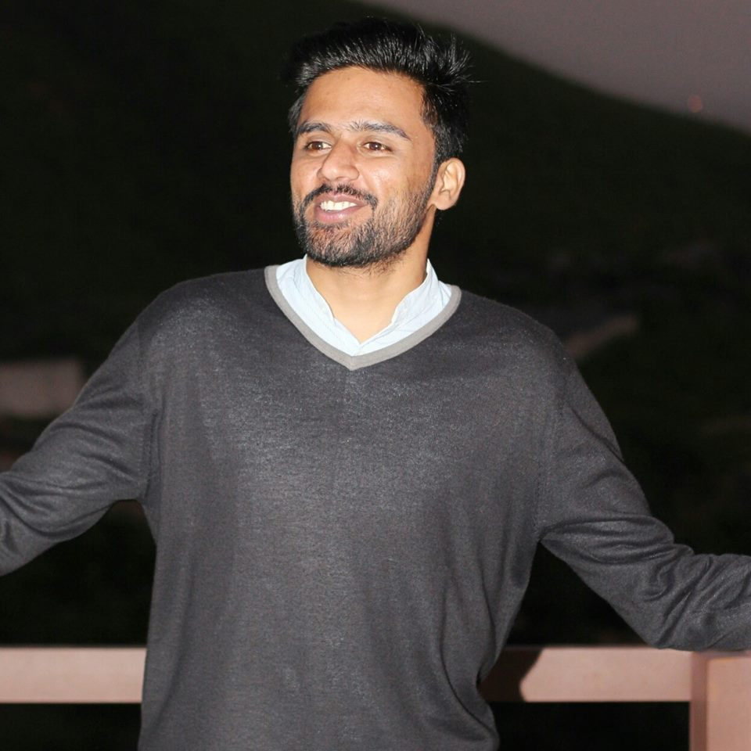

|  |  |
| --- | --- |
| **Bahria University**  **Islamabad Campus**  **Email:**atif_azh@yahoo.com.com  **Mobile:** +92 334 4158444 |  |

|  |  |  |
| --- | --- | --- |
| **Objective: To serve a reputable organization and prove myself as an efficient and effective resource and to succeed in an environment of growth and excellence and earn a job which provide me job satisfaction and self development and help me achieve personal as well as organizational goals.** | | |
| **Education** | | |
| **2013-17**  **[[[2010-12**  **2008-10** | **Bachelor of Computer Engineering (BCE), Bahria University Islamabad Campus, Islamabad.**  **(HSSC) Cadet College Jhelum. 1st Div.**      **(SSC) Cadet College Jhelum. 1st Div.** | |
| **Semester Projects** | | |
|  | * **DataBase and Data Entry of organizations.** * **Traffic signal generation with bi-color LEDs using PIC 18F series Micro controller.** * **Generic board of PIC18F series (software designing and hardware)** * **Networking Protocols.** * **DataBase of Banks and Office environments.** | |
| **Final Year Project (3rd position in open house BUIC 2017):**  **Autonomous Drone and its application for Surveillance:** The project is to develop a software system on Arduino for its autonomous flight, obstacle avoidance and make a live video as an input.   * **Arduino for rotors behavior.** * **Obstacle detection through UV sensors.** * **GPS for navigation.** | | |
| **Skills** | | * **Impeccable communication and presentation skills** * **C++** * **DataBase and Management.** * **Digital Networking.** * **MS Word** * **MS Power Point including basic know-how of MS Excel and MS Access.** |
| **Personal Interest** | | * **Sports, team member of Bahria University Basketball and Football team.** * **Oversaw the sports activities of BYTE Olympiad as Sports Director.** * **IT, Digital Media, social networking.** * **Photography, Arts & Philosophy.**  **Can work comfortably in any computerized environment..** |
| **Experience** | | * **Worked as IT manager in Socially High Marketing Islamabad (1 year)** * **To deal with all Computer related task and fulfill their requirements.** * [**www.sociallyhighmarketing.com**](http://www.sociallyhighmarketing.com) * [**sociallyhighmarketing@gmail.com**](mailto:sociallyhighmarketing@gmail.com) |
| **Passport**  **Information** | | **Atif Iqbal s/o Muhammad Sabir**  **Passport No:- TM1334491**  **Issue date :- 23 jan 2018**  **Expiry date :- 23 jan 2023**  **DOB :- 13th sep, 1993 (Jhelum)**  **Nationality :- Pakistani** |