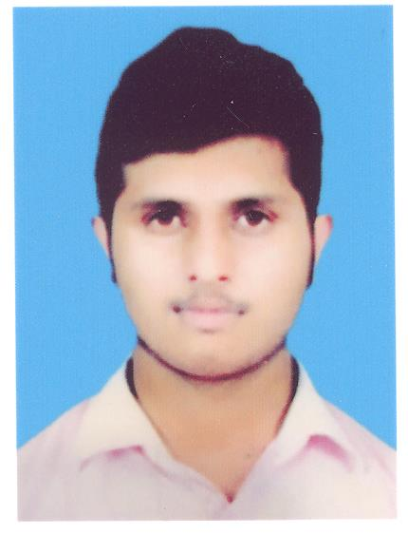

R

E

S

U

M

E

# ***MEHRAN AHMAD***

**Address: House No.20-F/252 POF,**

**WahCantt, Tehsil Taxila, District Rawalpindi.**

**Contact: 0324-5272690**

**OBJECTIVE:**

**A challenging position in the progressive environment of some reputable organization, where I could utilize my abilities best.**

**PERSONAL INFORMATION:**

**Father’s Name : Riaz Ahmed**

**C.N.I.C # : 37406-9946097-9**

**Date of Birth : 09-04-1996**

**Domicile : Rawalpindi (Punjab)**

**Gender : Male**

**Marital status : Single**

**Religion : Islam**

**Nationality : Pakistani**

**ACADEMIC QUALIFICATION:**

|  |  |  |  |  |
| --- | --- | --- | --- | --- |
| **Degree /Certificate** | **Marks** | **Year** | **Board** | **Division** |
| **S.S.C(Science)** | **507/1050** | **2013** | **FBISE** | **2nd** |
| **F.C.S(Science)** | **533/1100** | **2015** | **FBISE** | **2nd** |

**EXPERIENCE:**

**NO**

**Computer Skills:**

* **Internet Browsing**
* **MS Word**
* **MS Power Point**

**PERSONALITY CHARACTERISTICS:**

* **Dedicated.**
* **Excellent approach towards problem solution.**
* **Capable of working as an individual and a part of the team.**

**REFERENCE:**



* **Reference will be furnished on demand**.