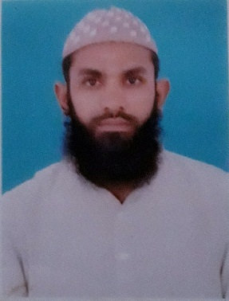***AMIR SOHAIL***

House no # Street # 3 near Ladies Park Nizamabad

Bazar Ghaziabad Lahore

Cell: 0336-4173313

Cell: 0323-4740904

Email: amirsadiq1994@gmail.com

**PERSONAL**

Father Name: Sardar Muhammad

CNIC: 35201-1329245-9

DOB: January 01, 1994

Marital Status: Single

Religion: Islam

**EDUCATION**

2017 **Gov. College of Technology Railway Road Lahore affiliated with**

**University of Engineering and Technology Lahore**

BSc Mechanical Engineering Technology

GPA 3.044

2013 **GCT Railway Road Lahore**

3 Years Diploma in Associate Engineering (Mechanical Technology)

Grade (A+)

2010 **BISE Lahore**

Matriculation (science group)

Grade (A+)

**PROFESSIONAL EXPERIENCE**

JUNE 2017 – Present **KOMAX Pvt Ltd**

**CNC Programmer cum Operator.**

Produces machined parts by programming, setting up, and operating a computer numerical control (CNC) machine; maintaining quality and safety standards.

DEC, 2016 - MAY 30, 2017 **Infinity School of Engineering**

**Trainee CNC programmer**

06 months hands on training on CNC programming and other

Software like power mill, AUTO CAD and CAD CAM etc.

18 WEEKS **Pakistan Railways Workshops**

**Industrial Training Program**

Overview of different mechanical shops of Pak Railways including carriage and wagon shops, spring shop, foundry shop, Millwright shop, power shop and diesel classified shop.

**OTHER WORK EXPERIENCES**

12, JULY 2012 INTERNSHIP IN MANAN SHAHID FORGING

To 28 JULY 2012 INDUSTRY (2 WEEKS)

**KNOWLEDGE & SKILLS**

* CAD/CAM
* Power mill
* CNC Programming
* MS Office
* Typing & Other Computer Tool
* Operating System