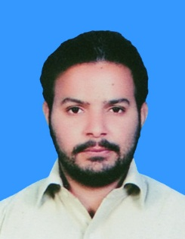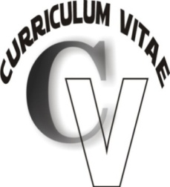**AHMED ALVI**

**Contact information:**

**Father Name WarisAlvi**

**CNIC no 31202-5880906-9**

**Mailing Address: House No. 256, B-II Street NearMultani Gate Bahawalpurpakistan.**

**Permanent Address: House No. 256, B-II Street Near Multani Gate Bahawalpurpakistan.**

**Mob #: +92 322 6857041**

**E-mail:** [**ahmedalvi3@gmail.com**](mailto:ahmedalvi36@yahoo.com)

**Personal information:**

**Date of Birth: Sep 26, 1992.**

**Gender: Male.**

**Nationality: Pakistani.**

**Marital Status: Single.**

**Languages Known: English, Urdu, Sariki,and Punjabi.**

**Personal Skills: Positive Attitude, Patience, Goal Oriented.**

**Hobbies/ Interests:Playing Cricket, Meeting People, Traveling.**

**Objective:**

Looking for joining an organization in a challenging Mechanical Engineering field where I could sharpen my skills and utilize them for the enhancement of the company for better economical and future benefits.

**Academic Qualification:**

**BSc Mechanical Engineering & Technology Dr.A.Q khan institute mianwali affiliated with**

**1st division UET Lahore.**

**2013-17**

**Bachelors of commerce Allama Iqbal Open University**

**B.com Islamabad.**

**1st division 2018**

**Diploma of Assosiate Engineer Govt.College of Technology**

**DAE Mechanical Bahawalpur.**

**1st division 2008-11**

**Secondary school certificate (metric) Board of intermediate and secondary education**

**1st division Bahawalpur. 2006-2008**

**Work Experience:**

**Sr.MECHANICAL TECHNICIAN CHASHMA NUCLEAR POWER PLANT  
July 2018-september 2018 PAKISTAN ATOMIC ENERGY COMMISSION**  
 CHASHMA SITE MIANWALI-PAKISTAN

Responsible for working as part of a team that repairs mechanical problems.  
Duties;

* Developing, testing and make modifications to mechanical equipment.
* Safely operated equipment and tools to complete project.
* Working on REACTOR COOLANT PUMP.
* Removed and repaired various equipment’s and components of RCP and CCP.
* Assisting with Mechanical Installations.
* Preventive maintenance of centrifugal charging pump (CCP).
* Mechanical Oil seals and general bearing removing and fixing.
* Alignment of moving shaft.
* Completing all duties according to applicable safety measures and published procedures.
* Using screwdrivers, wrenches, socket wrenches, pliers, hammers, chisels and punches to troubleshoot and repair complex equipment problems.
* Inspection, preventive, breakdown maintenance, overhauling of plant equipment.

**Internships and trainings**

**Pakistan locomotive railway works**December 2016-March 2017  
**mughalpura Lahore**

**KEY SKILLS AND COMPETENCIES**

Professional

* Technical documentation and reporting.
* Proficient in MS office programs such as Word and Excel.
* Constant attention to detail.

Personal

* Having an analytical mind.
* Ability to problem solve in a logical way.
* Excellent punctuality and attendance record.

**Engineering Technical certification and diplomas:**

|  |  |  |  |
| --- | --- | --- | --- |
| **Certificate** | **Year** | **Grade** | **Institute** |
| **Auto CAD Mechanical** | 2011 | A | Pakistan Industrial Technical Assistant Center Lahore. |
| **CNC Machining Center** | 2010 | A | Pakistan Industrial Technical Assistant Center Lahore. |
| **Mechanical Drafting & Auto CAD** | 2012 | A | National Training Bureau Islamabad |

**Computer Skills:**

* Office Management
* Internet
* Microsoft Windows
* Hardware/ Software

**References:**

Certificates will be provided if required.