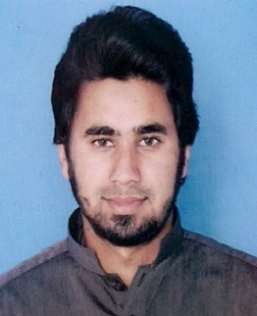**Yahya Aziz**

**Address:** 874 E Block Canal View Society, Lahore

**Cell:** +92-3224553223

**Email:** yahyaaziz70@yahoo.com

**Objective**

To secure a challenging position that provides an opportunity to grow and excel in the field of Electrical Engineering by utilizing problem solving, planning and organizational skills to achieve corporate goals.

**Education**

* **BSc. Electrical Engineering** **CGPA: 2.92**

Sharif College of Engineering & Technology Lahore 2014-2018

(Affiliated with UET Lahore)

* **FSc. (Pre-Engineering)**  2012-2014

Board of Intermediate & Secondary Education, Lahore

* **O Level GCSE**  2010-2012

University of Cambridge

**Internship**

**Wapda (LESCO) Duration: 13-6-2016 to 25-7-2016(6 weeks)**

*132KV Substation, Garden Town Lahore*

**Tasks & Responsibilities**

* Power Transformer Monitoring
* 132KV / 11KV Line Monitoring
* Overall Substation Monitoring

**Core Courses**

Electric Circuits Analog & Digital Electronics

Circuit Analysis & Design Semiconductor Devices

Power Generation, Distribution and Utilization Power System Analysis

Power System Operation & Protection High Voltage Engineering

Control System Digital Logic Design

Power Electronics Machine Design

**Skills**

ETAP AUTOCAD

MATLAB MULTSIM

Proteus Power World Simulator

Pspice KEIL µvision

Arduino Dev-C++

Microsoft Word Microsoft Excel

Microsoft Power Point MS Project

**Projects**

***Final Year Project***

Portable Solar Power Air Conditioner

***Semester Projects***

Obstacle Avoiding Robot based on Cortex M4

Band Pass Filter

AM Receiver

5V Power Supply

Metal Detector

**Workshop/Certificates**

**Energy Crisis: “Rationale for Renewable Energy” and “Soft Skills and Tools for Professional Engineers”**

*Held at Sharif College of Engineering & Technology Lahore.*

**“Arduino for Newbies”**

*Held at Sharif College of Engineering & Technology Lahore.*

**Interests & Activities**

Travelling

Cricket

Football

Voluntary work

**References**

Shall be furnished on request.