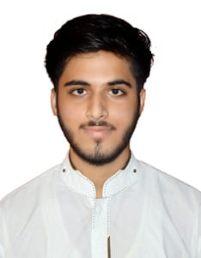

**ARSLAN RAZA**

|  |  |  |  |
| --- | --- | --- | --- |
| Telephone 🕿 |  |  |  |
|  | Mobile | +92-315-9605848 |
|  |  |  |  |

**Address: P.O Kala Dev Tehsil & District. Jhelum**

**bObjective**

Quite enthusiastic to be associated with a progressive and growth oriented organization that gives scope to apply my abilities and skills with hard work and determination and to be part of the team that dynamically works towards the growth of the organization.

b

***Professional skills***

* Knowledge of Computer

Strict adherence to organizational policies and rules

* Professional appearance and manner
* Good Communication & inter personal skills leading to strong decision making power
* Effective time management & Committed to work
* Strong analytical skills
* Co-ordination & communication in organizational channel to attain given targets, while acting as team member
* Punctuality

b

***Computer skills***

* MS office (word, excel, power point)
* Internet searching/social networks
* Editing/Copy/Paste

b

***Short Course***

Short Course of CNC MACHINE OPERATOR from PBTE Lahore from 19 Sep 2016 to 18 March 2017.

b

***Academic Profile***

|  |  |  |  |  |
| --- | --- | --- | --- | --- |
| **Qualification** | | **Board/University** | **Year of completion** | **Division** |
| Matric (science) | Rawalpindi Board | | 2015 | Grade “A+” |
| DAE (Mechanical) | Lahore Board | | 2018 | A |

**b**

***Languages***

* Urdu, English, Punjabi

b

***Personal profile***

Father’s Name: **Asif Ali**

Marital Status: **Single**

Gender: **Male**

Date of Birth: **22-10-1998**

Nationality: **Pakistani**

CNIC: **37301-7904129-9**

Domicile: **Jhelum b- Punjab**

**Reference**

Will be furnished upon request.