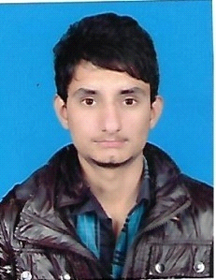 *Curriculum vitae*

**NAME**  **:** Ahtisham Khalid

**Address :** Malik colony girja road Chuck jilaal din Rawalpindi

**Mob :** 0347-5430544

**Email :** [Ahtishamkhalid683@gmail.com](mailto:Ahtishamkhalid683@gmail.com)

*Personal DATA*

**Nationality :** Pakistani

**Sex :** Male

**Marital status :** Single

**Date of birth :** 22-01-1996

**Religion :** Islam

*EDUCATION:*

|  |  |  |  |
| --- | --- | --- | --- |
| **DEGREE** | **SESSION** | **MARKS** | **BOARD** |
| **SSc**  **DAE(MECHANICAL)**  **DIPLOMA**  **(I.T ADVANCE)** | **2011-2012**  **2013-2015**  **2016** | **567/1050**  **2560/3450**  **“A”GRADE** | **RBISE**  **PBTE**  **AGT INTITUTE** |

*COMPUTER SKILLS:*

**:6** month diploma of computer in IT advance

**:**Good command on basic computer Applications**.**

**:**MS Word-worked on Document reports.

:MS Excel

**:**Typing

:Networking

*WORK EXPERIENCE:*

:2 year experince in kfc frome 2016 - 2018

**:**Basic mechanical cnc machines

**:**Computer opreater at resaption

**:**MS word and MS excel

**:**Data entry job reseption

**:**2 year part time job in it field

*EXTRACURRICULAR*

*ACCTIVITES:*

**:**Good player crciket

**:**Computer application well known

**:**Organized and Well structured at Work

**:**Honest, and hard worker

*Objective:*

To pursue a challenging career in Daynamic and progressive organization with the aim of utilizing my knowledge and creativity fuerthernace of my own and the company’s objectives