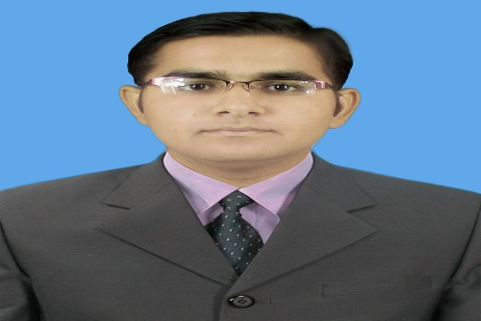

**MUHAMMAD ASADULLAH  
QURESHI**

ASSISTANT MAINTAINER

(DAE MECHANICAL)

**date of birth**.

25-08-1994

# Objective

TO GET START WITH A WELL REPUTED ORGANIZATION FOR GIVING MY BEST.

## Skills & Abilities

Troubleshooting and Maintenance of Mechanical equipment’s.

## PHYSICAL ADDRESS

D-83 NEW COLONY CHASHNA BARRAGE, DISTT. MIANWALI

**P # 03068070388**

asadullah.qureshi8@hotmail.com

### Education

#### diploma of associate engineering

##### in mechanical technology

#### Dr. A.Q Khan Institute of technology, Mianwali

2012~2015

#### matriculation

##### With computer sciences.

GOVT. HIGH SCHOOL, WAPDA COLONY, CHASHMA

2010~2012

### courseS

**BASICS OF IT SOFTWARES**

PIXEL INSTITUTE OF COMPUTER SCIENCES, CHASHMA

### ExperienceS

#### CHASMA NUCLEAR POWER PLANT UNIT-1

##### DURING REFUELING OUTAGE-11 (2017)

##### shutdown assistant maintainer HVAC group

DIAGNOSING THE HEAT VANTILATION AND AIR CONDITIONING SYSTEMS AND ITS EQUIPMENTS AND RESOLVING ISSUES BY MAINTENANCE TECHNIQUES.

#### Chashma nuclear power plant unit-2

##### **DURING REFUELING OUTAGE-04 (2016**)

##### shutdown assistant maintainer turbine group

DIAGNOSING THE TURBINE AUXILIARIES EQUIPMENTS AND ASSIST IN MAINTAINING EQUIPMENTS

#### UNIQUE ELECTRO-mECHANICAL WORKS

2014~2016

ASSISTANT IC ENGINE MAINTAINER

LEARNING FIXING PRACTICAL IC ENGINES PROBLEMS BY USING MAINTENANCE TECHNIQUES

#### CHASHMA NUCLEAR POWER PLANT UNIT-2

**DURING REFUELING OUTAGE-05 (2017)**

SHUTDOWN ASSISTANT MAINTAINER PUMP GROUP

DIAGNOSING THE PUMP AUXILIARIES EQUIPMENTS AND ASSIST IN MAINTAINING EQUIPMENTS

#### CHASHMA NUCLEAR POWER PLANT UNIT-3

#### DURING REFUELING OUTAGE-01 (2018)

SHUTDOWN ASSISTANT MAINTAINER PUMP GROUP

DIAGNOSING THE PUMP AUXILIARIES EQUIPMENTS AND ASSIST IN MAINTAINING EQUIPMENTS

### REFERENCES

I solemnly undertake that all information / particulars given above are correct to the best of my knowledge and I have not concealed any information.